WEEK-12

1 DEPLOYMENT OF INDEX.HTML USING EC2 INSTANCE in AWS

* Go to course invitation mail and click on start
* Opens the aws academy, select the student login and enter the email and password details
* Click on Modules
* Scroll down and select Lunch AWS Academy Lab-🡪 start Lab

Click on start lab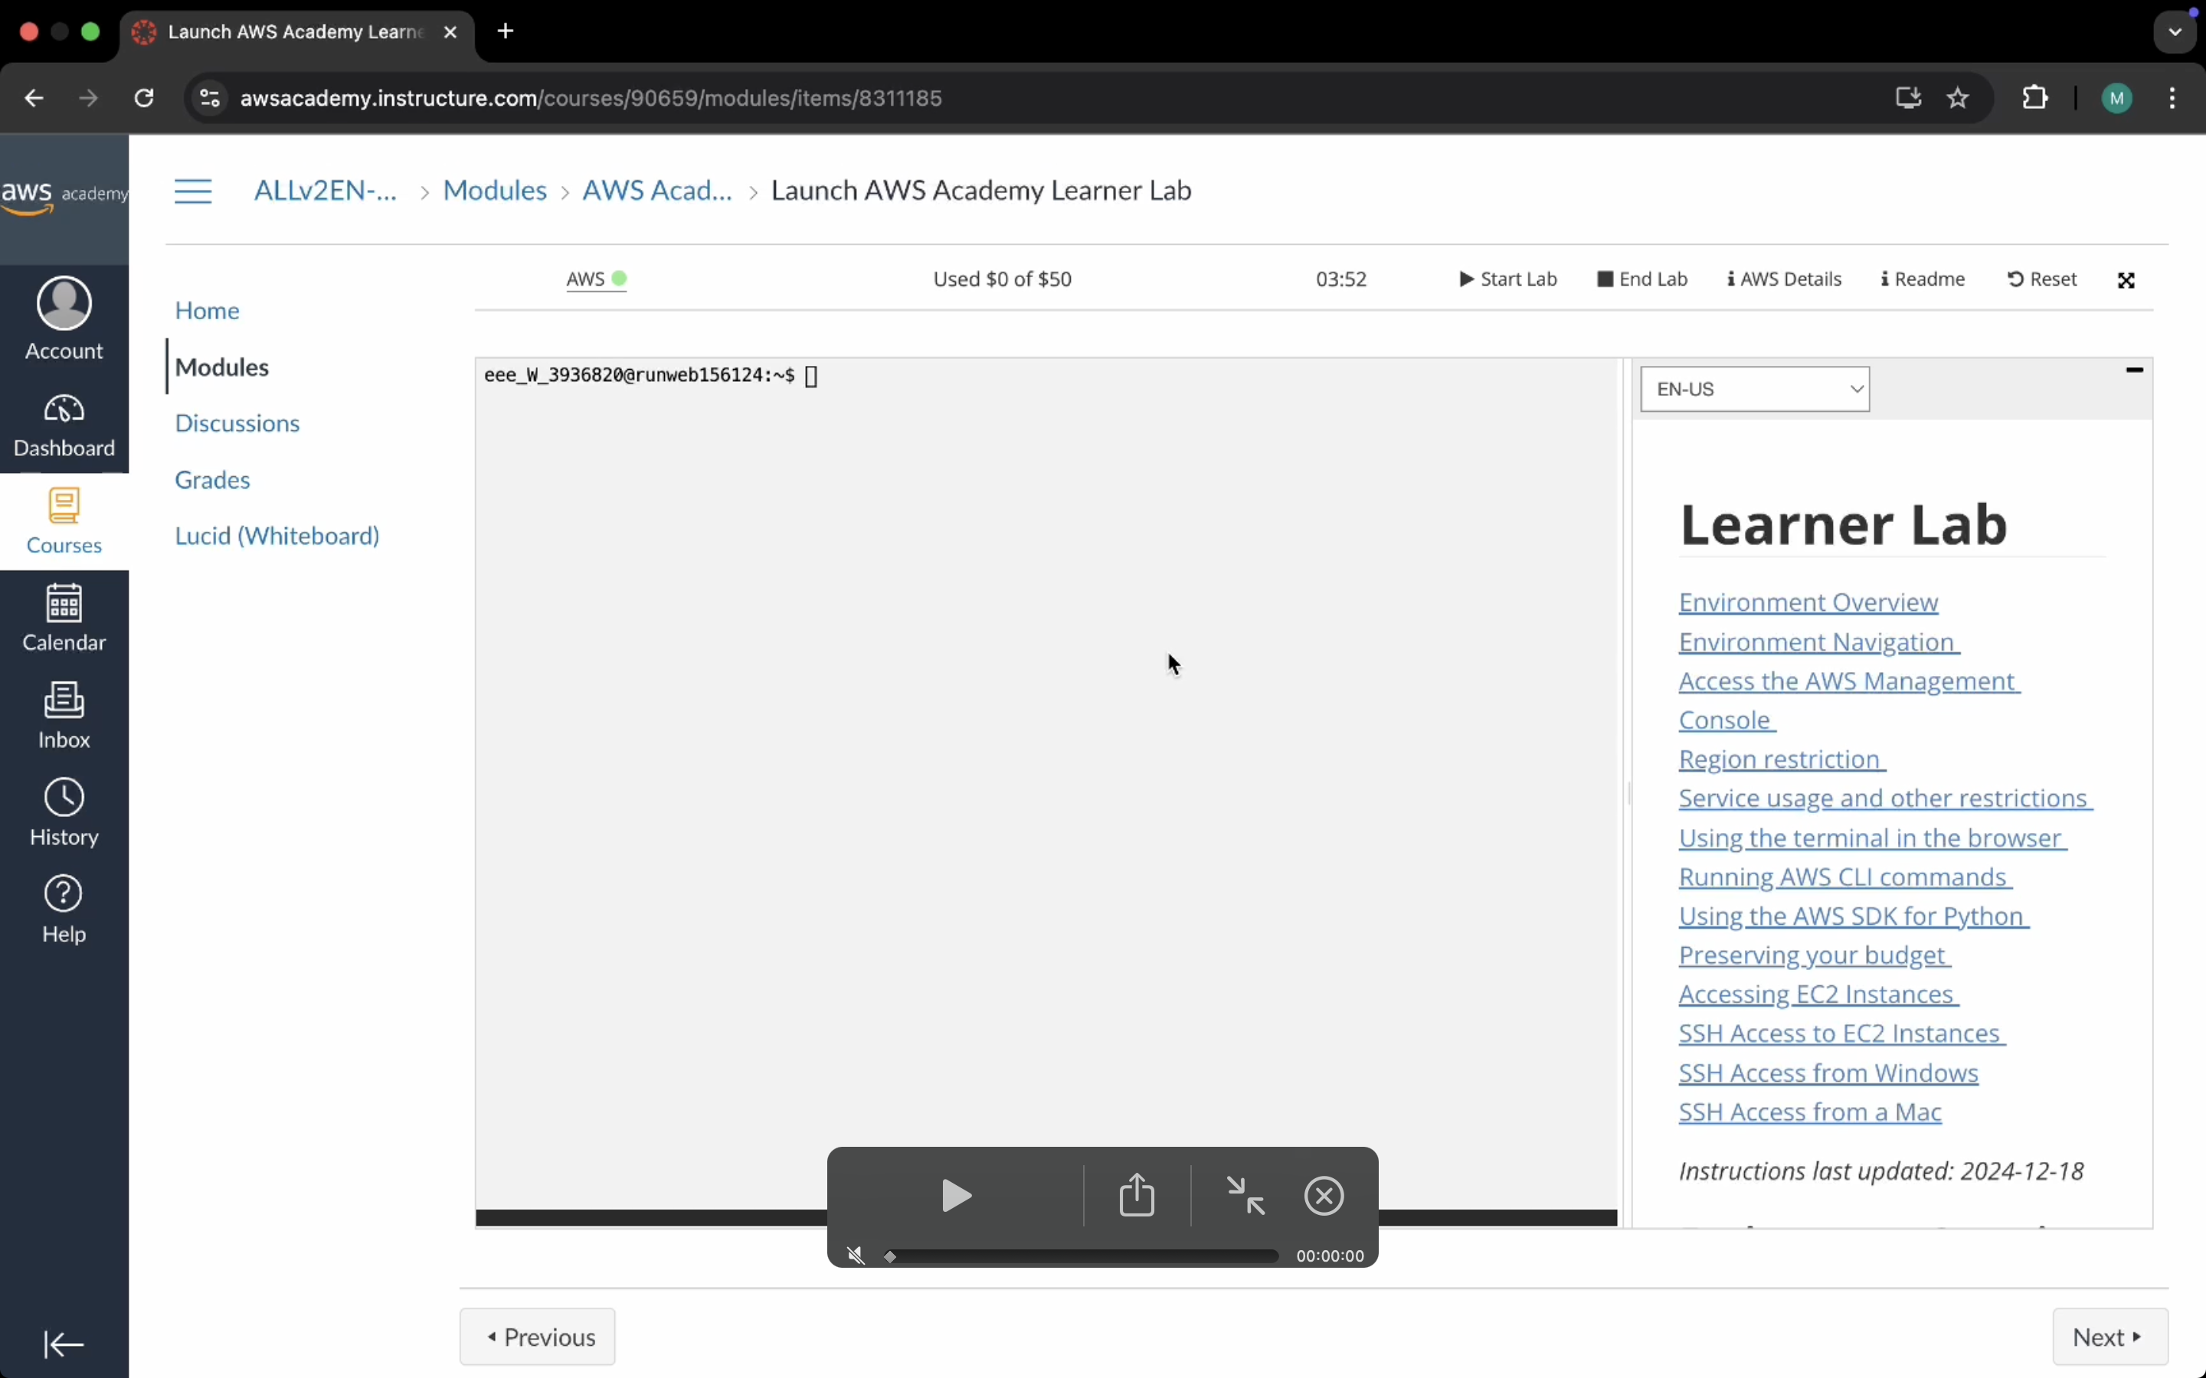

Click on AWS

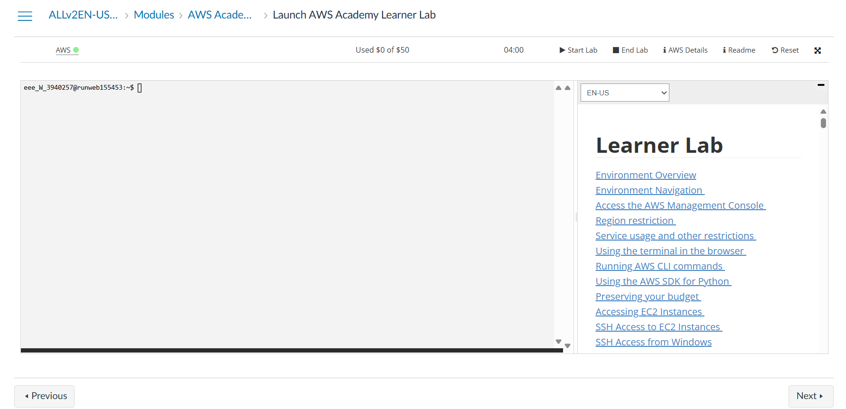

Click on EC2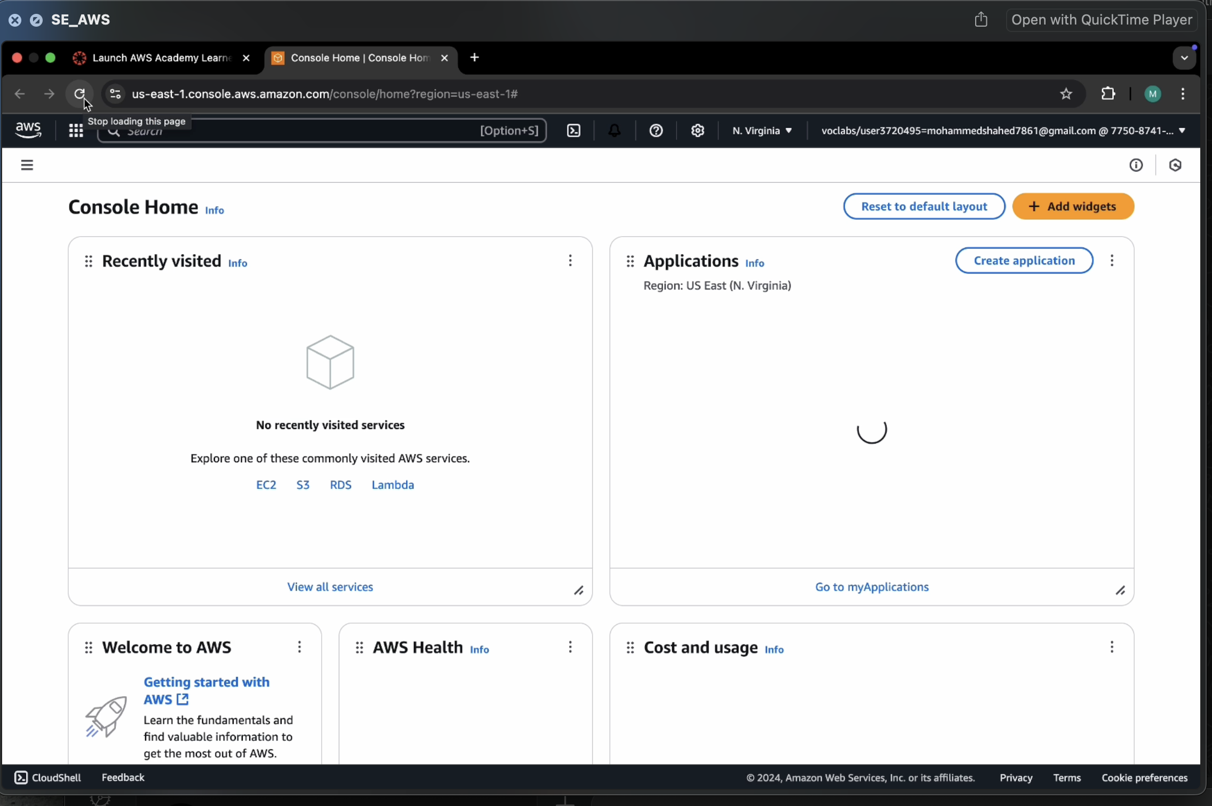

Click on Launch Instance

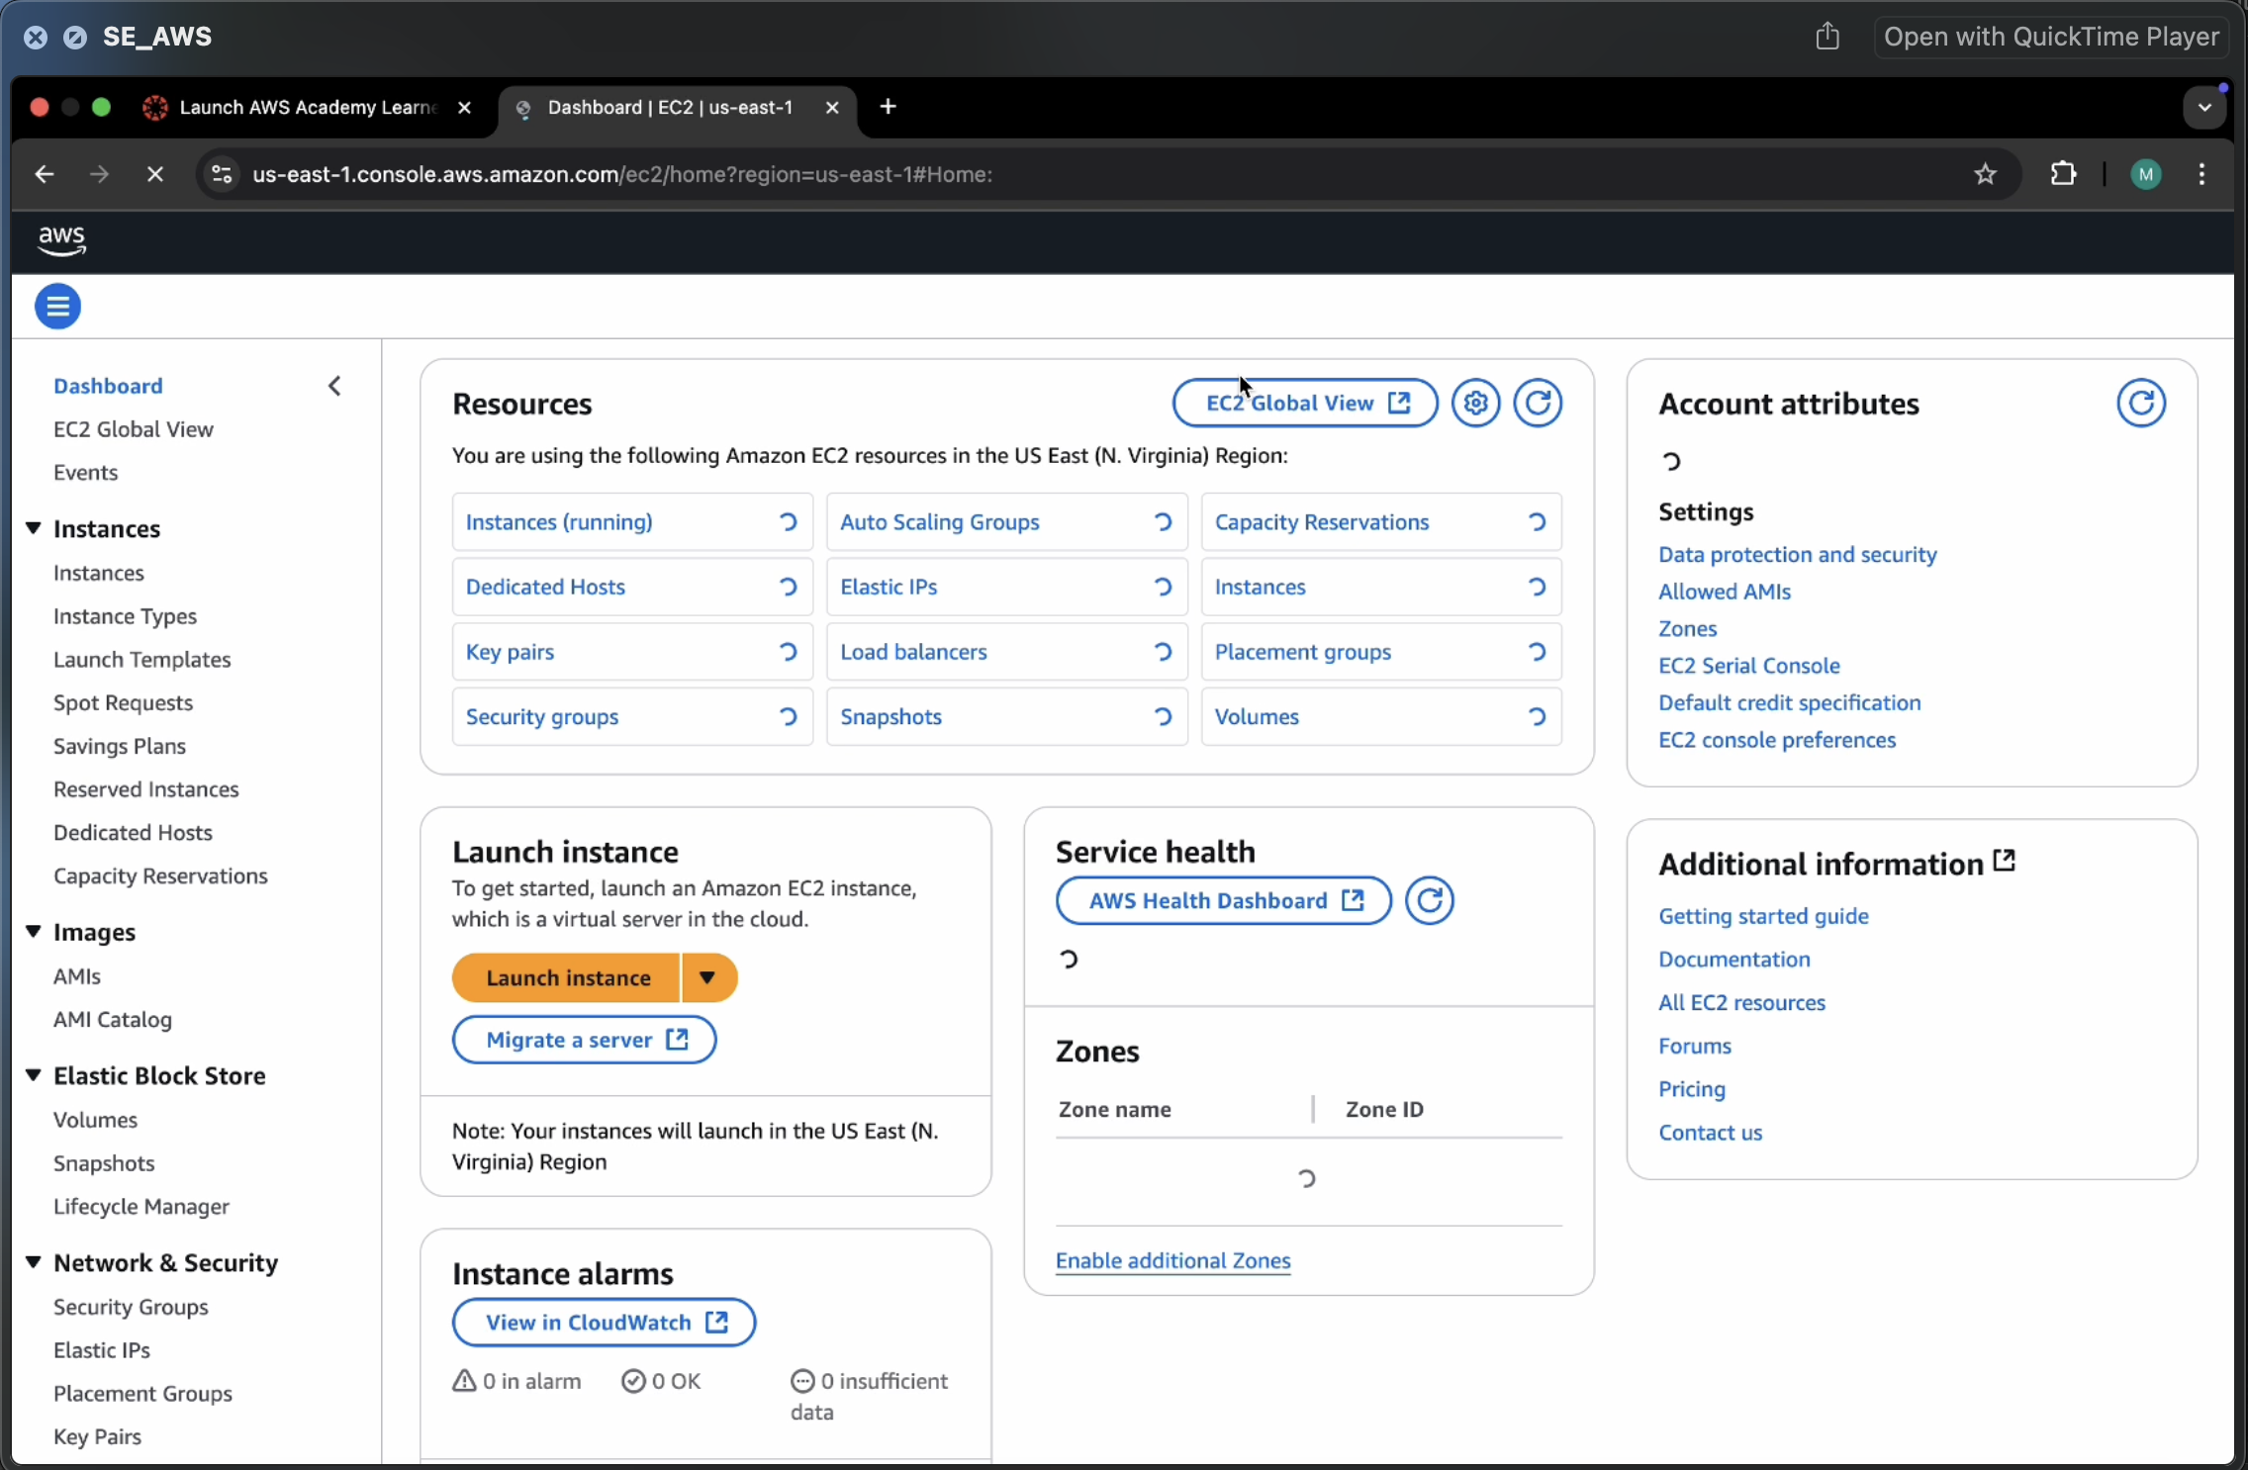

Give name and select ubuntu under application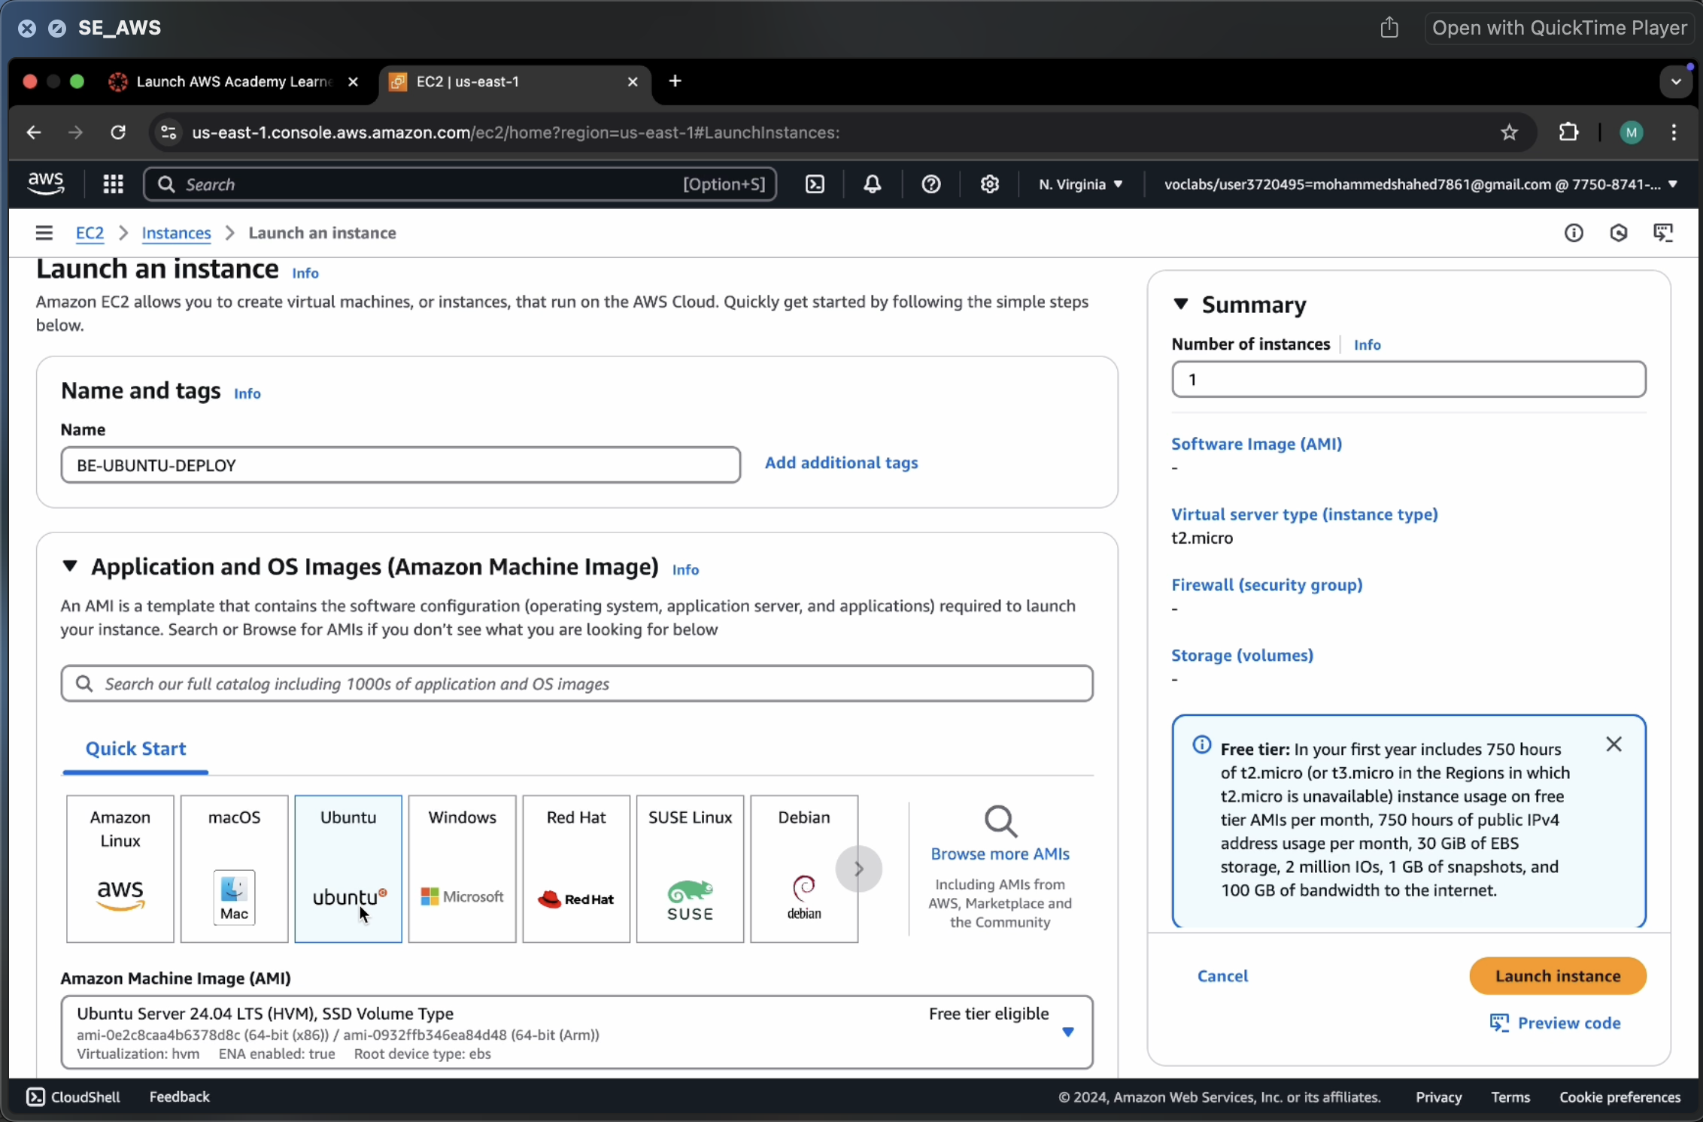

Make sure AMI and Architecture are there as shown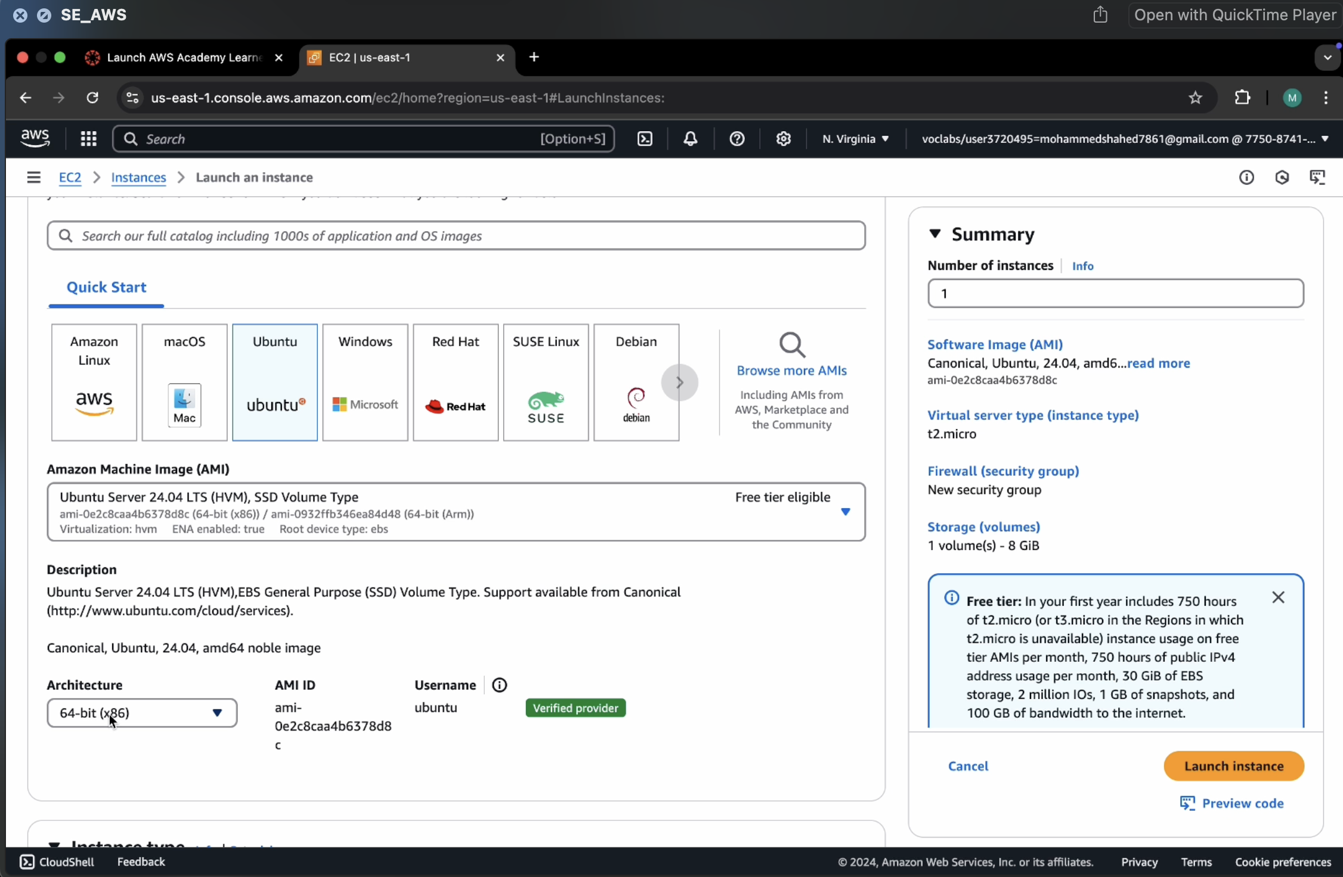

Click on create-new key pair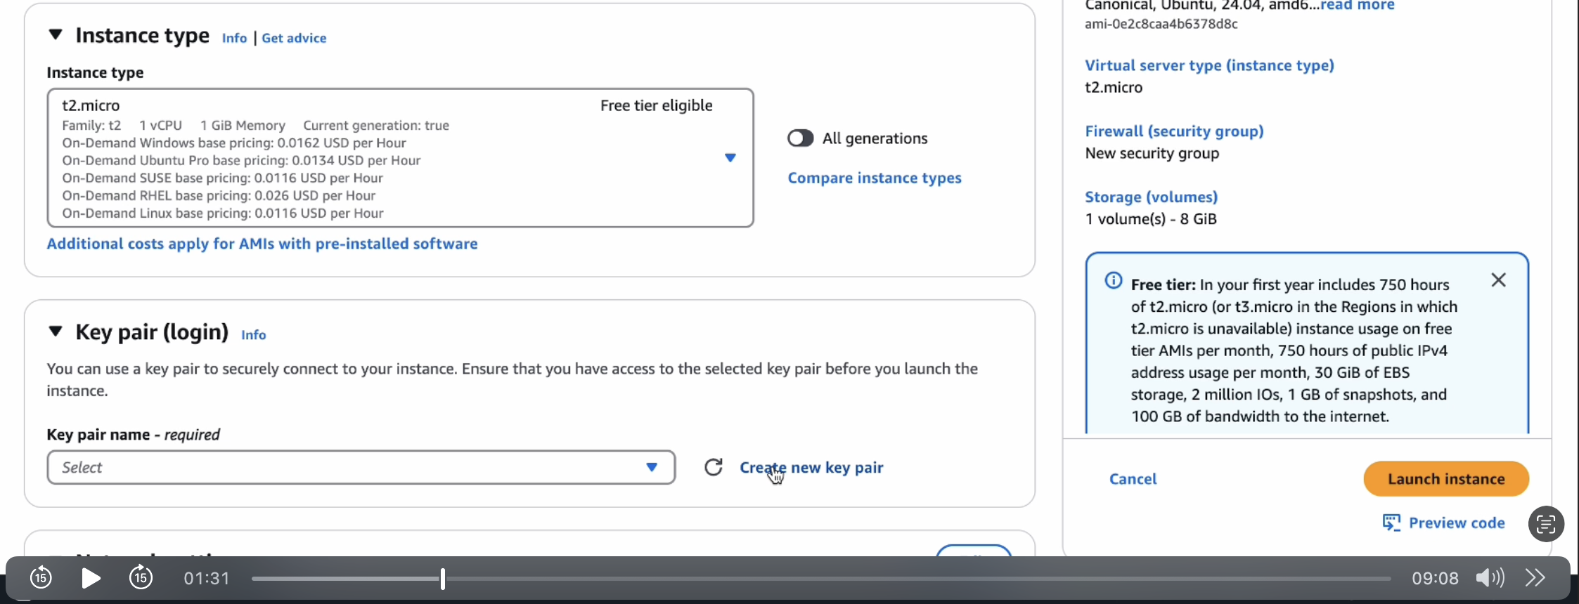

Give KeyPair name and click on create key pair

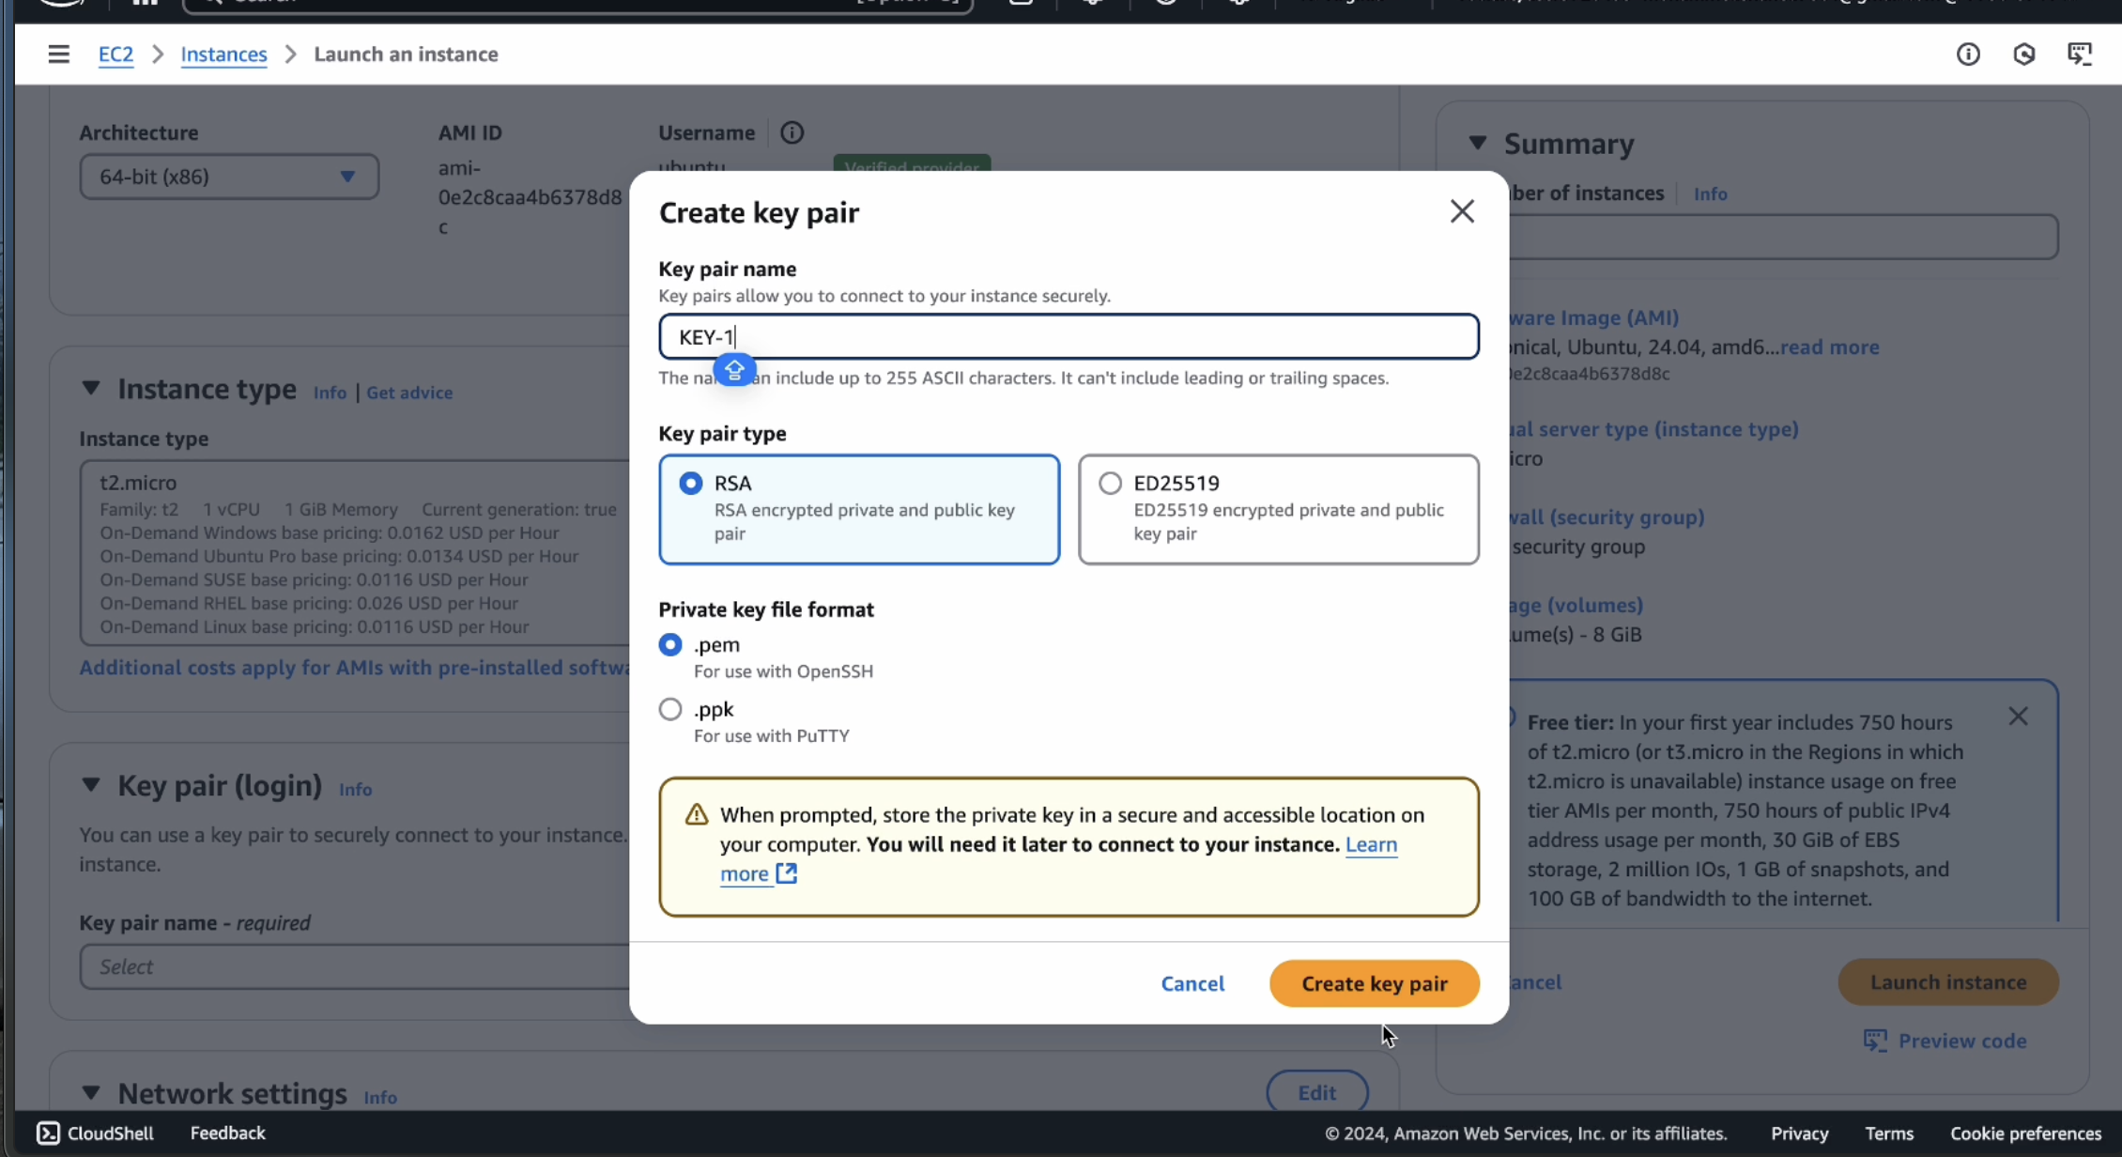

Save the .pem file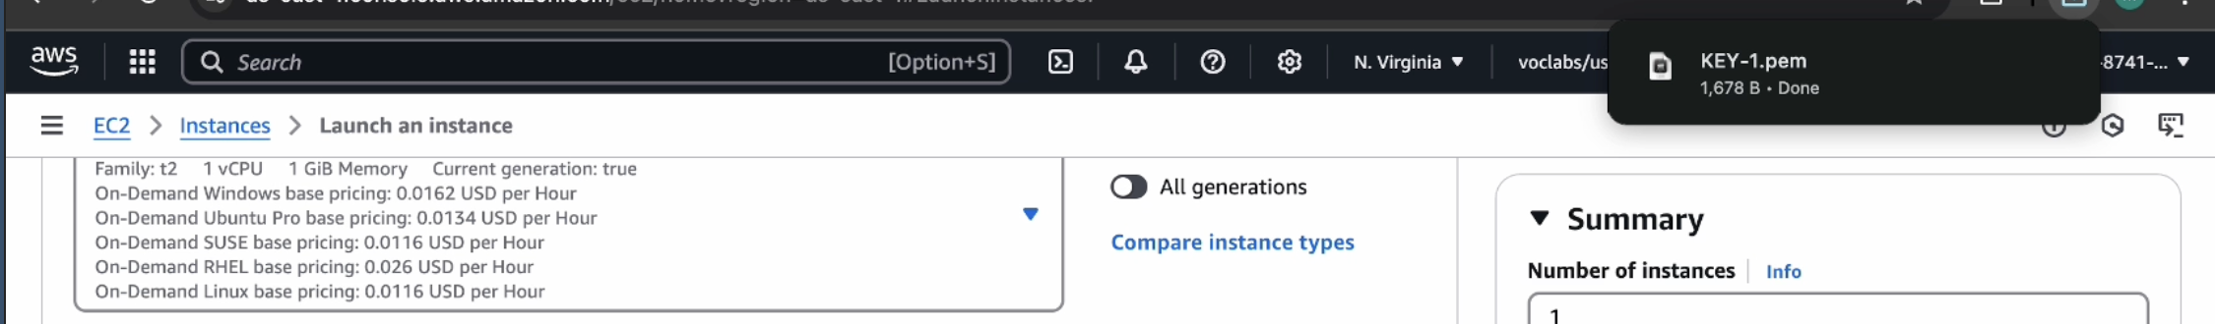

In network setting check all the checkboxes and click on launch instance which is at the bottom right to the page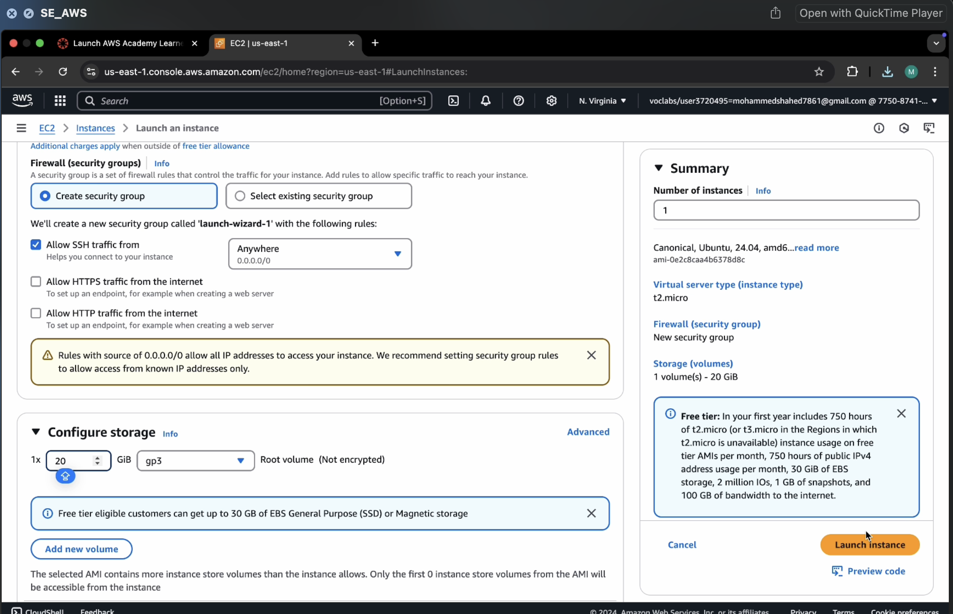

Wait for the Success message.

Now click on the instances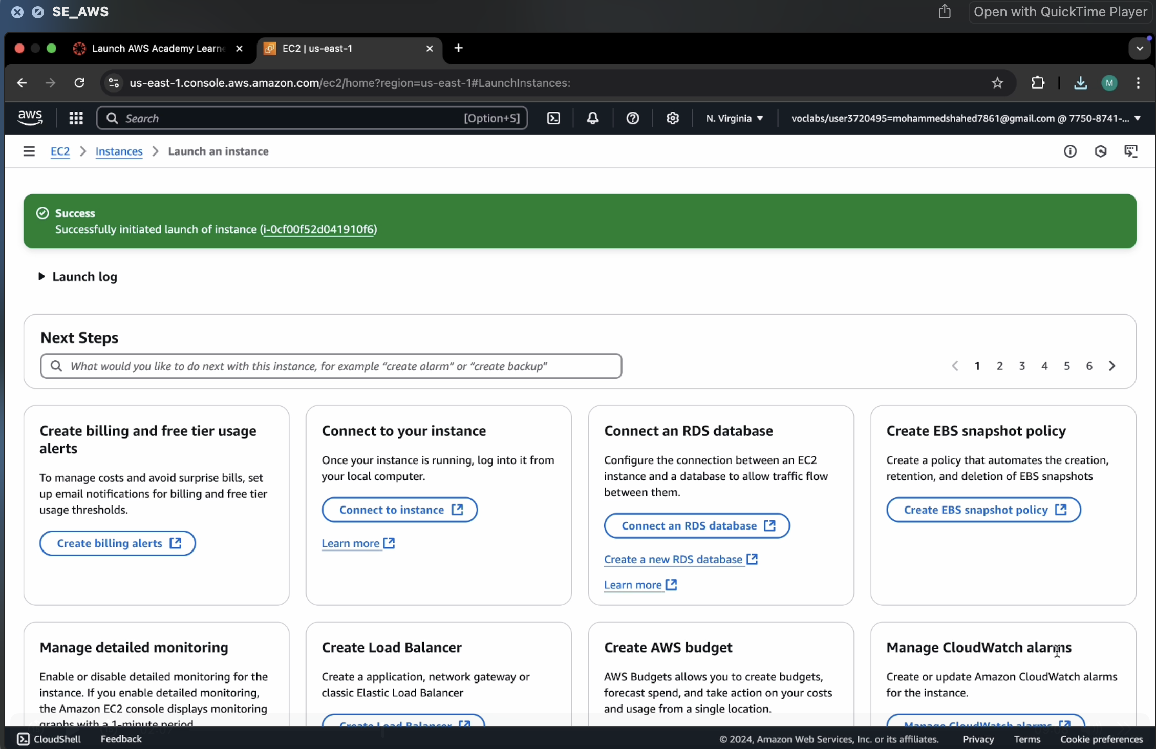

You can see BE_UBUNTU_DEPLOY is Running and wait for it to initialize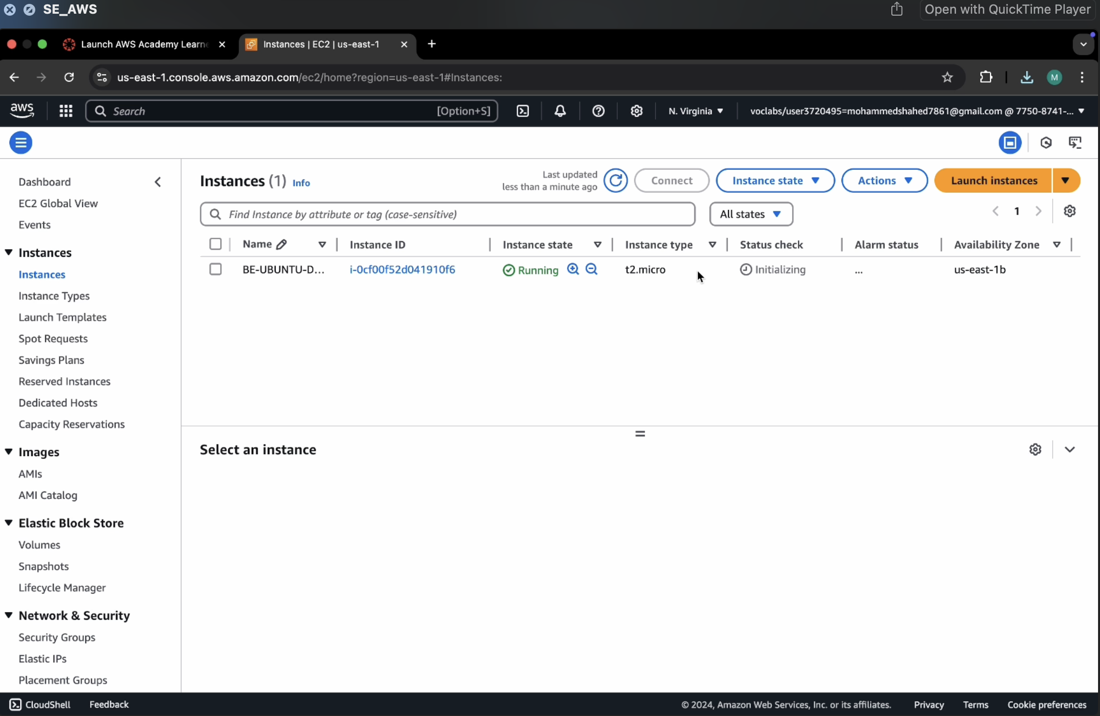

You have get 2 tests passes. Now check the box and click on connect.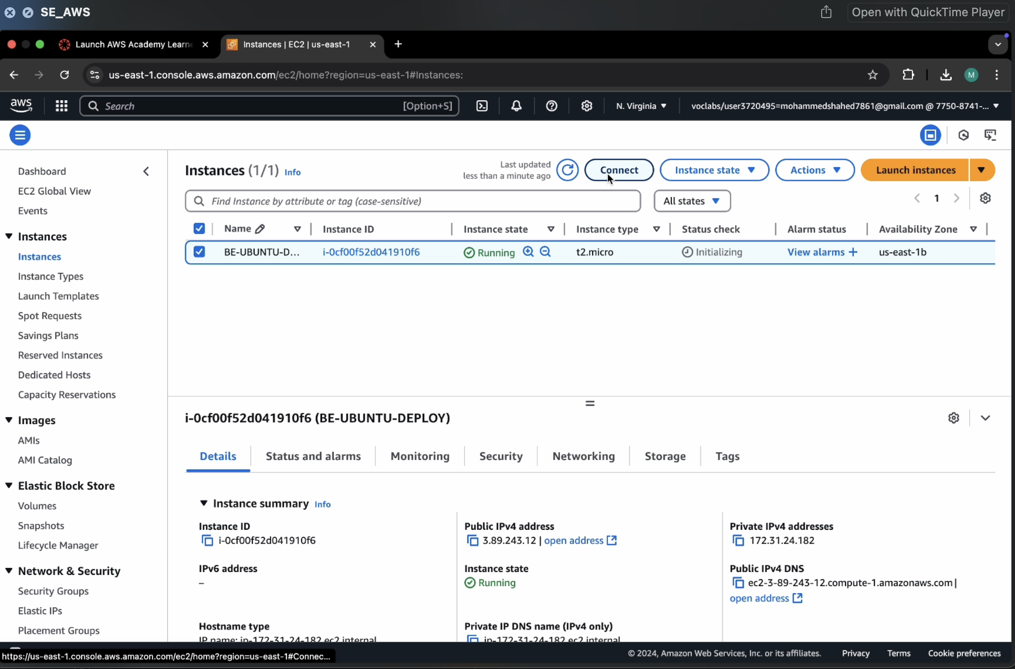

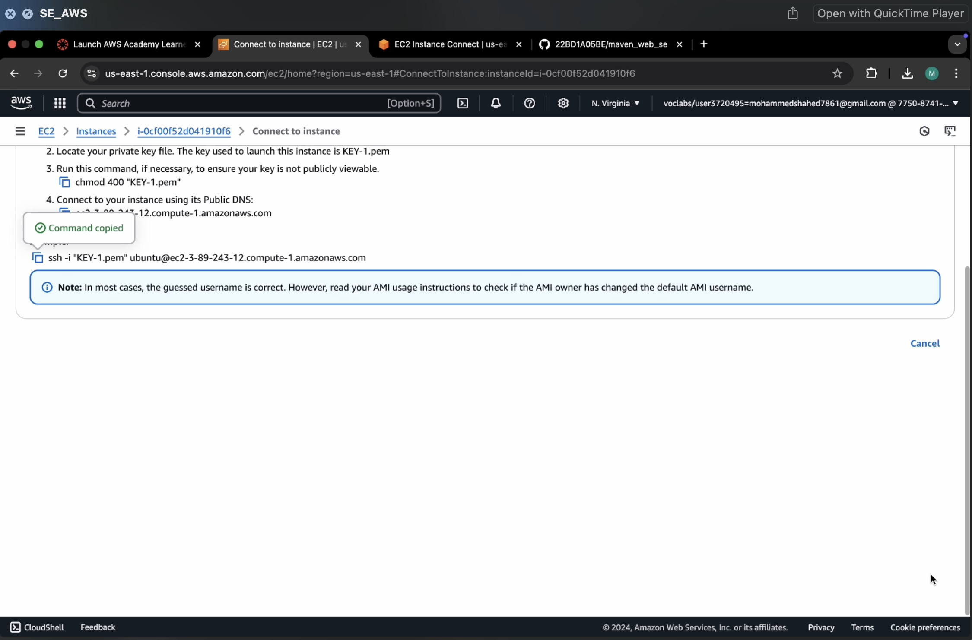Go to SSh and copy the command which is present at the below

Run the command in the terminal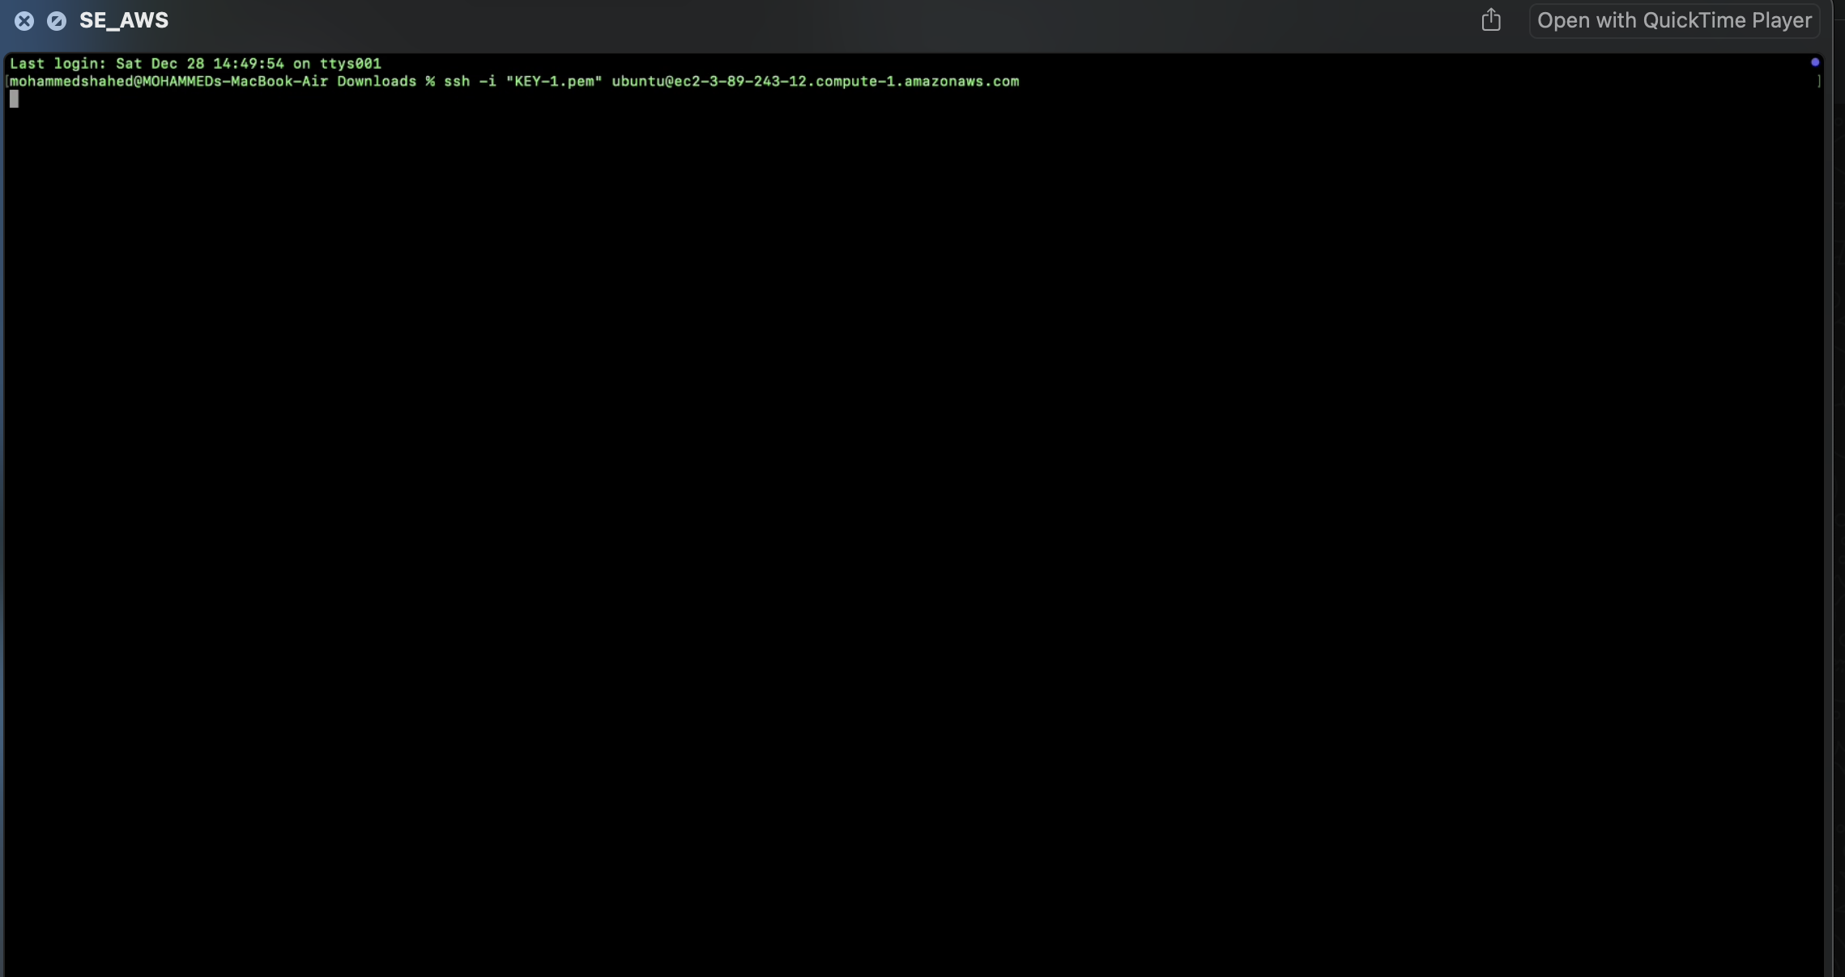

Run the following commands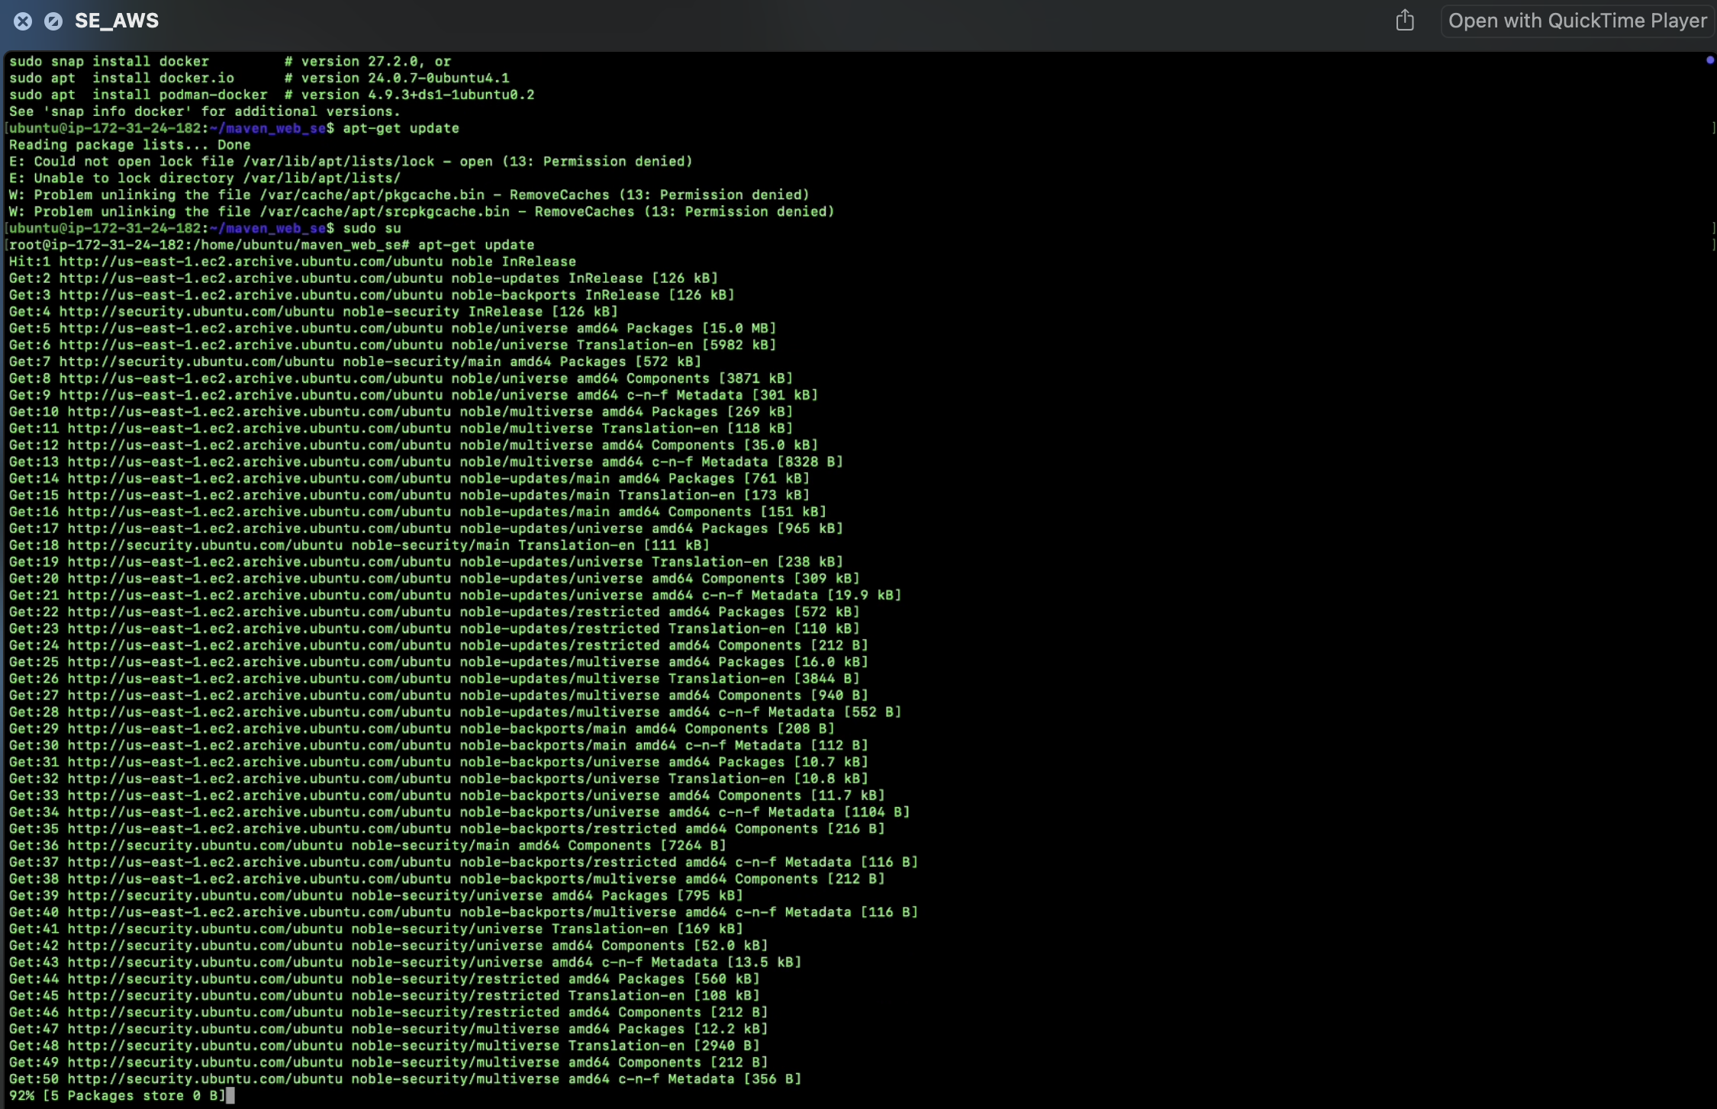

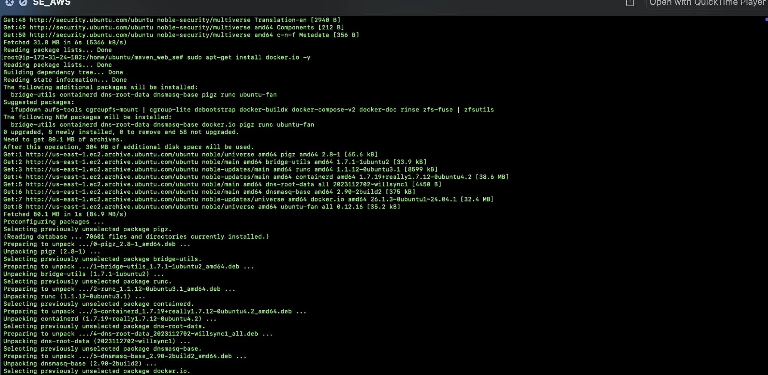

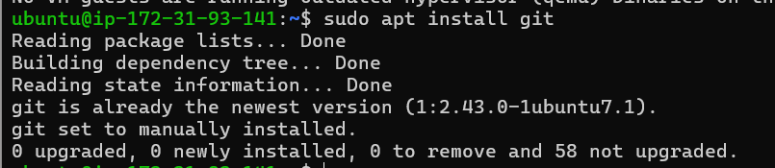

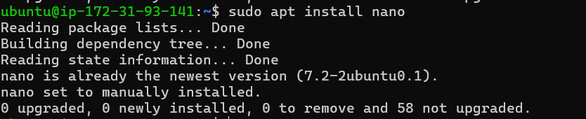

Create basic index.html file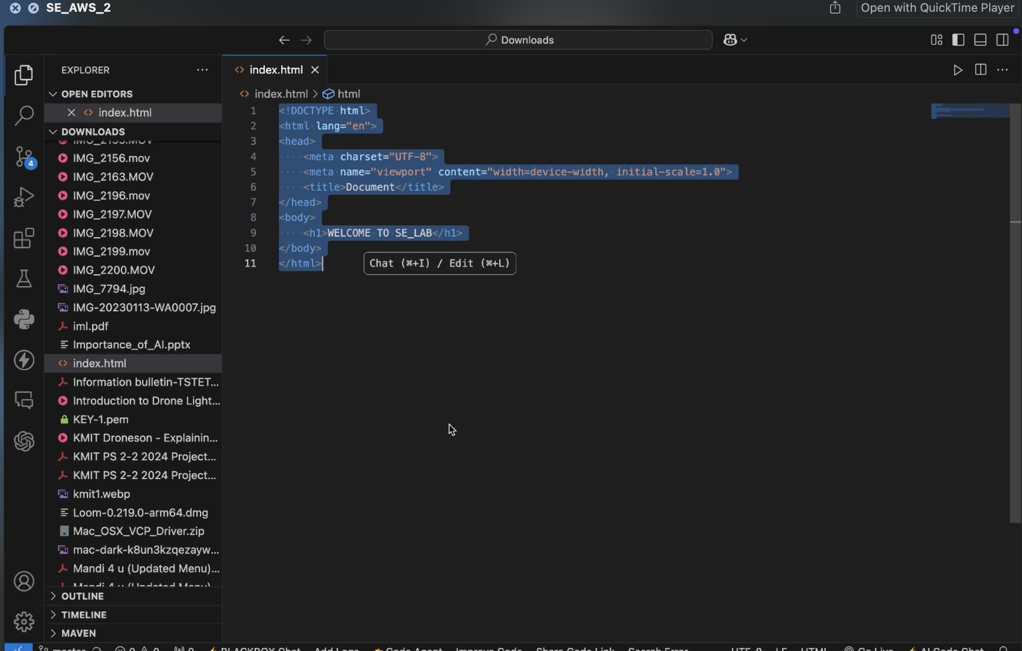

Create git repo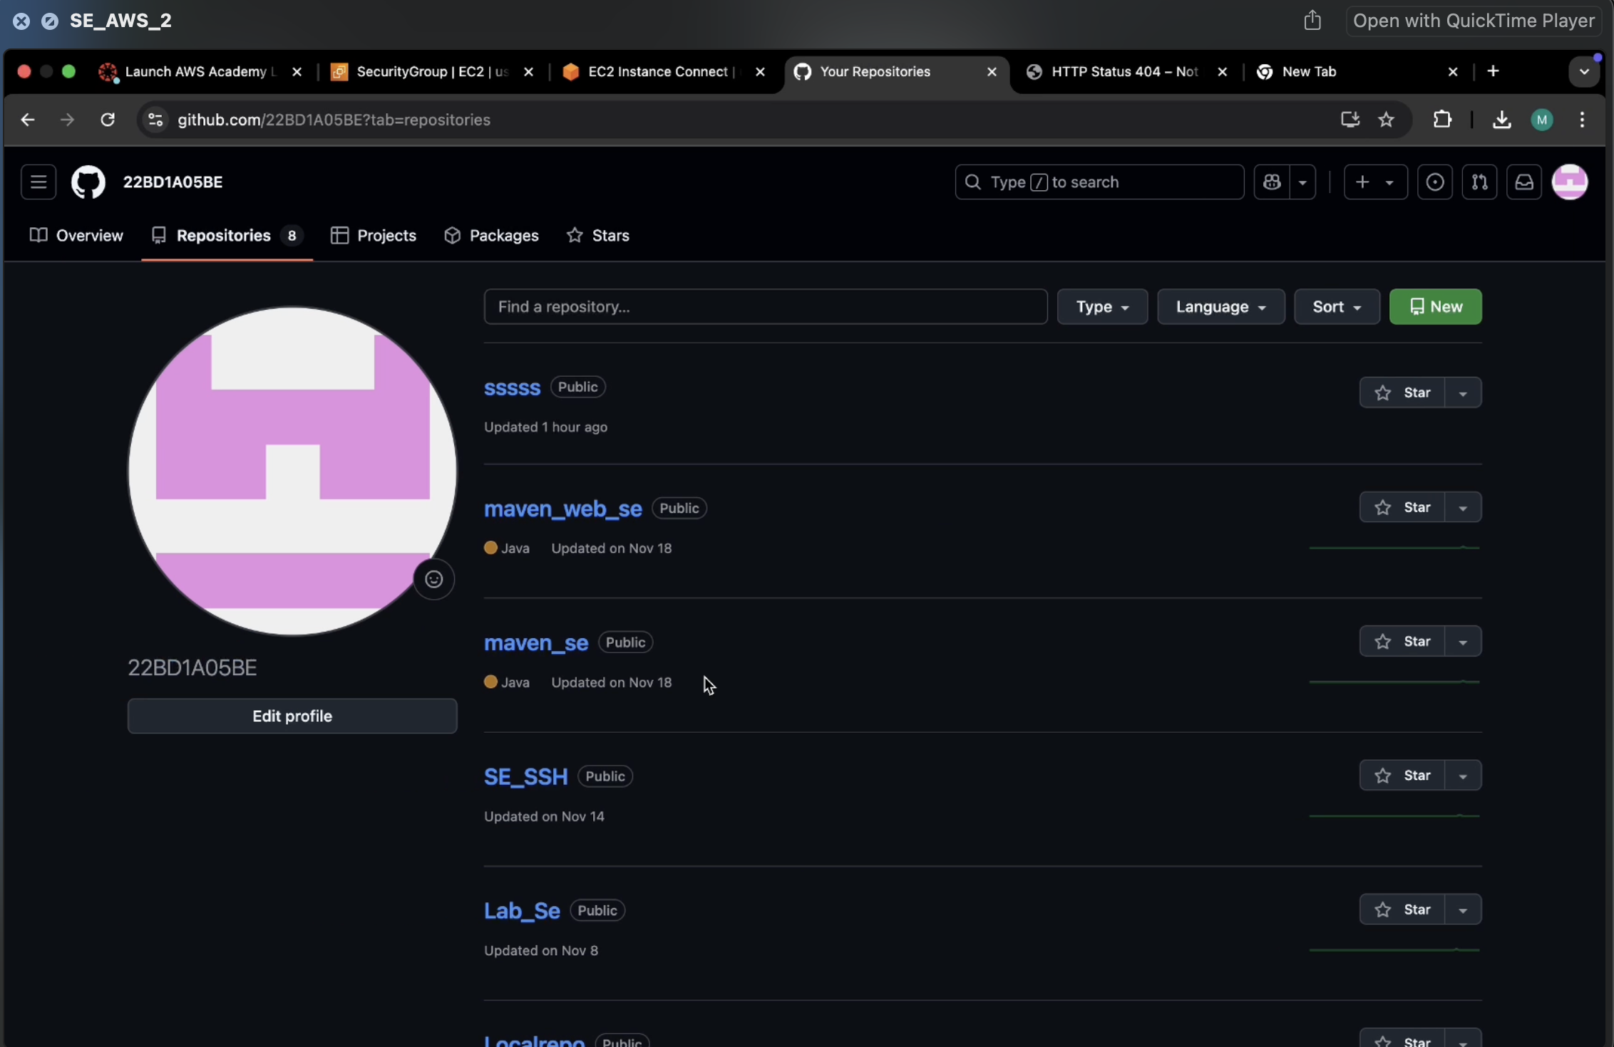

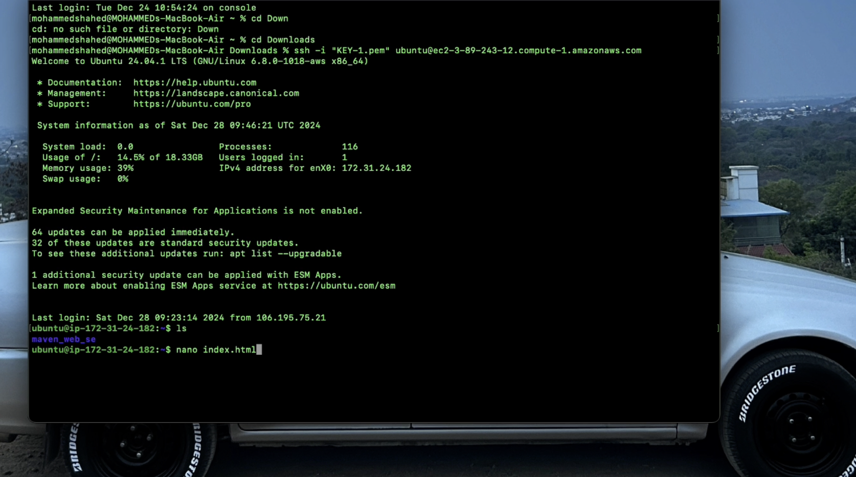

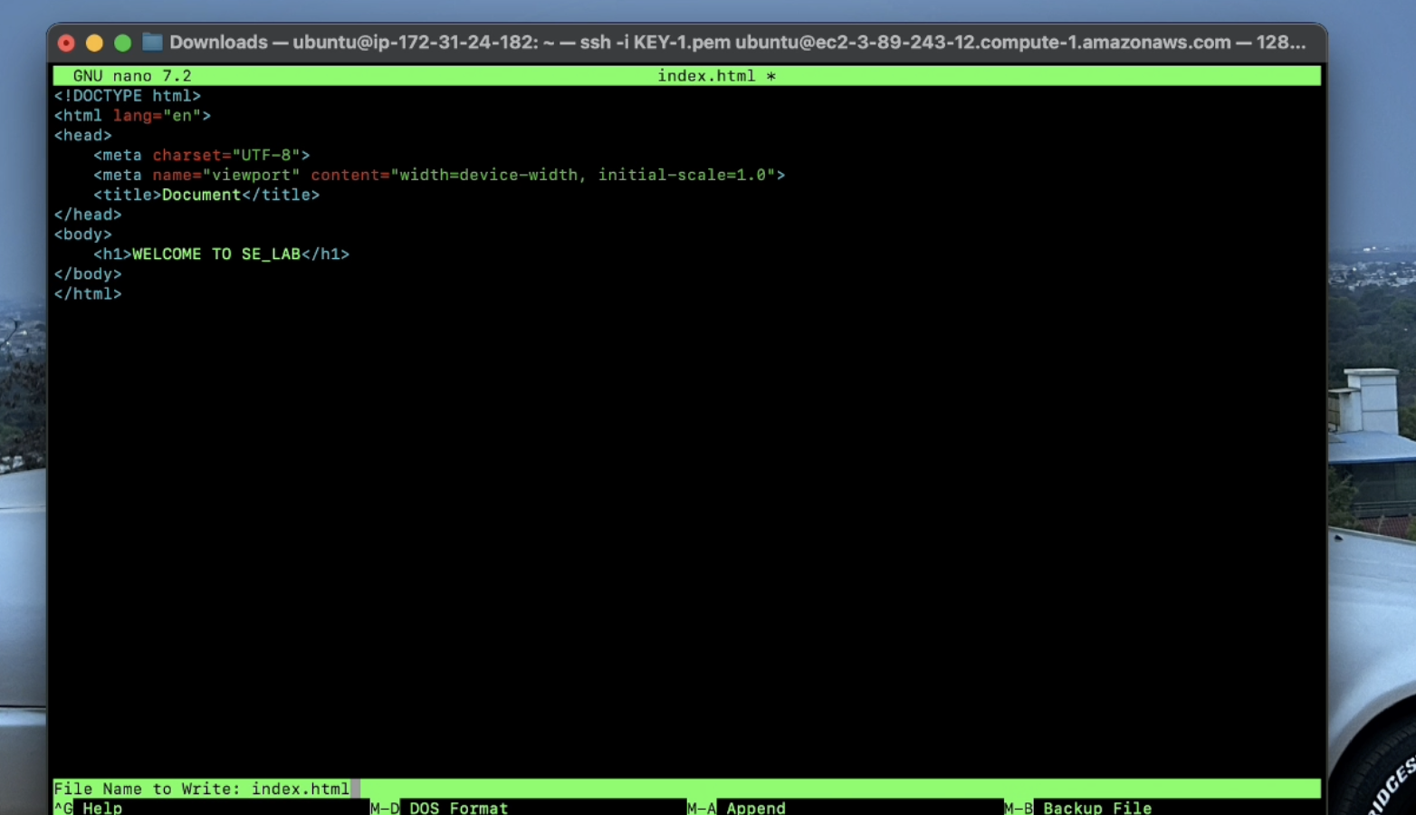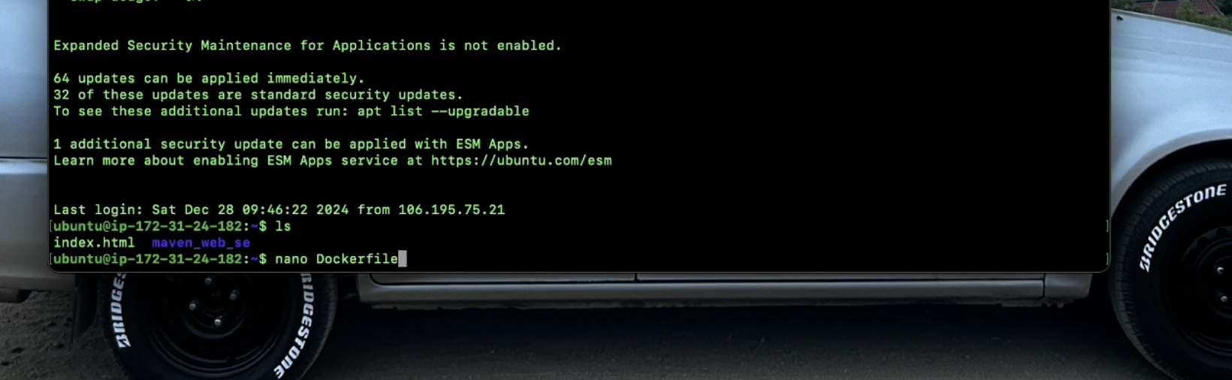

Write the following data in Dockerfile and click ctrl+o and ctrl-x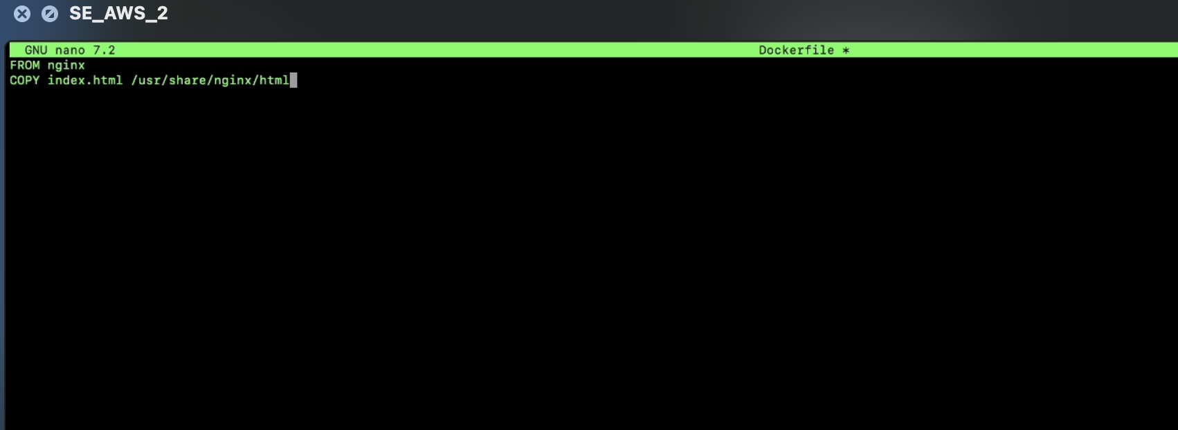

Build docker image by executing the following command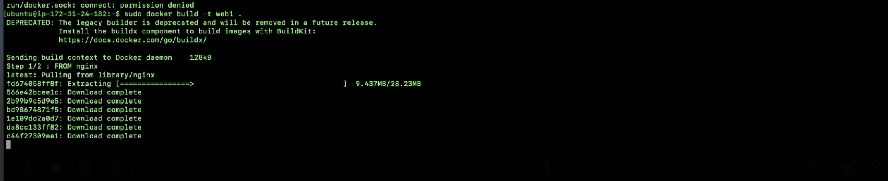

Run the container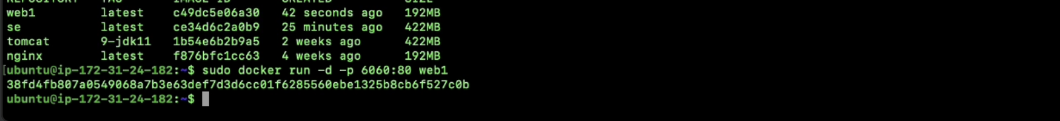

Click on

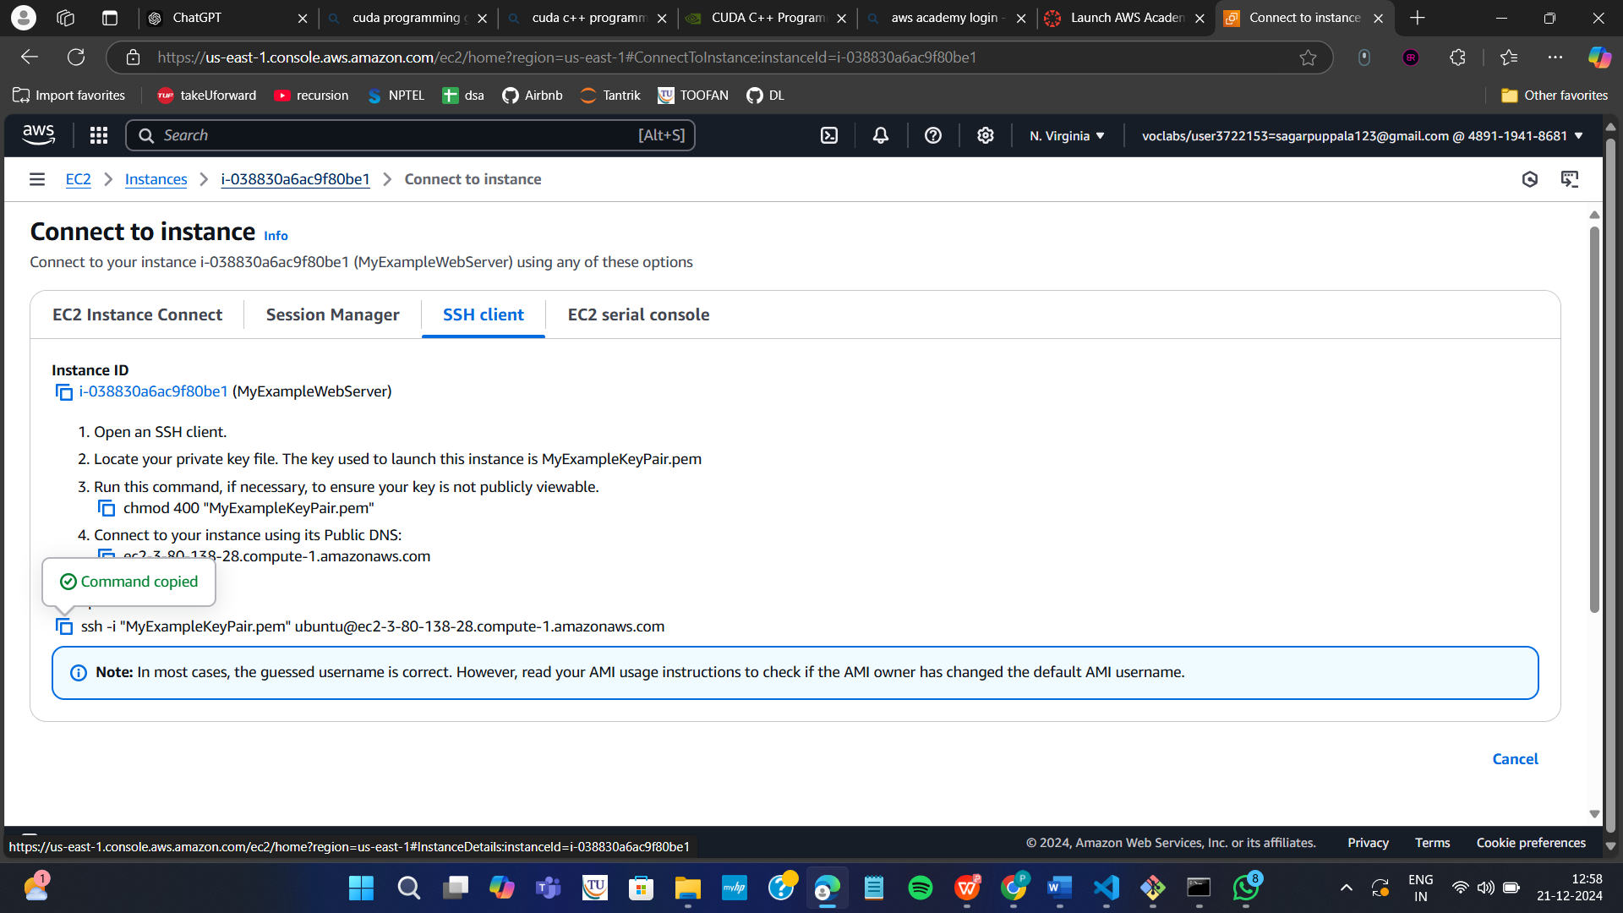

Copy public ip

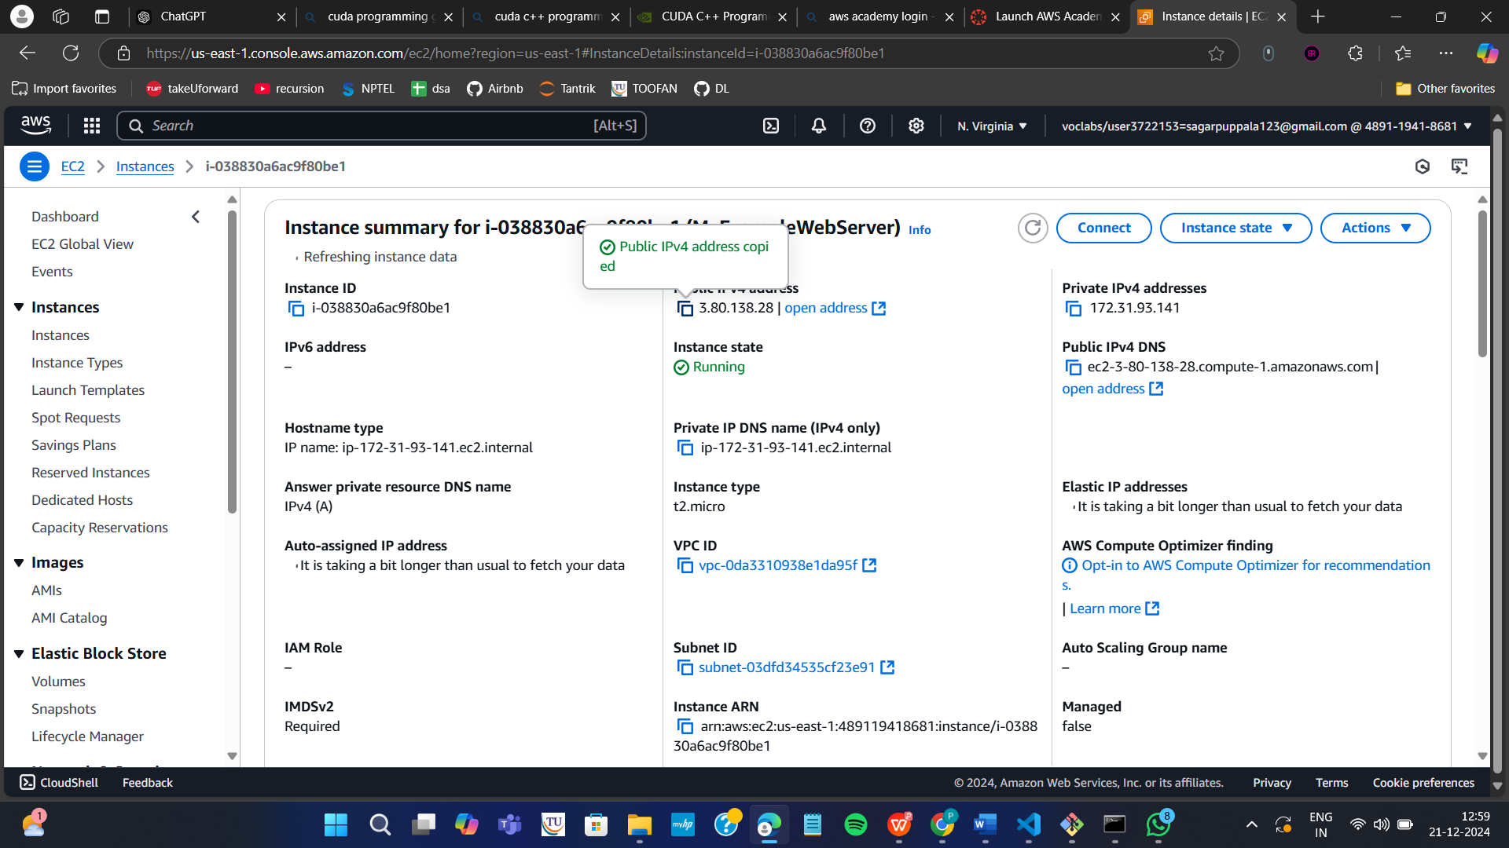

Paste it in the browser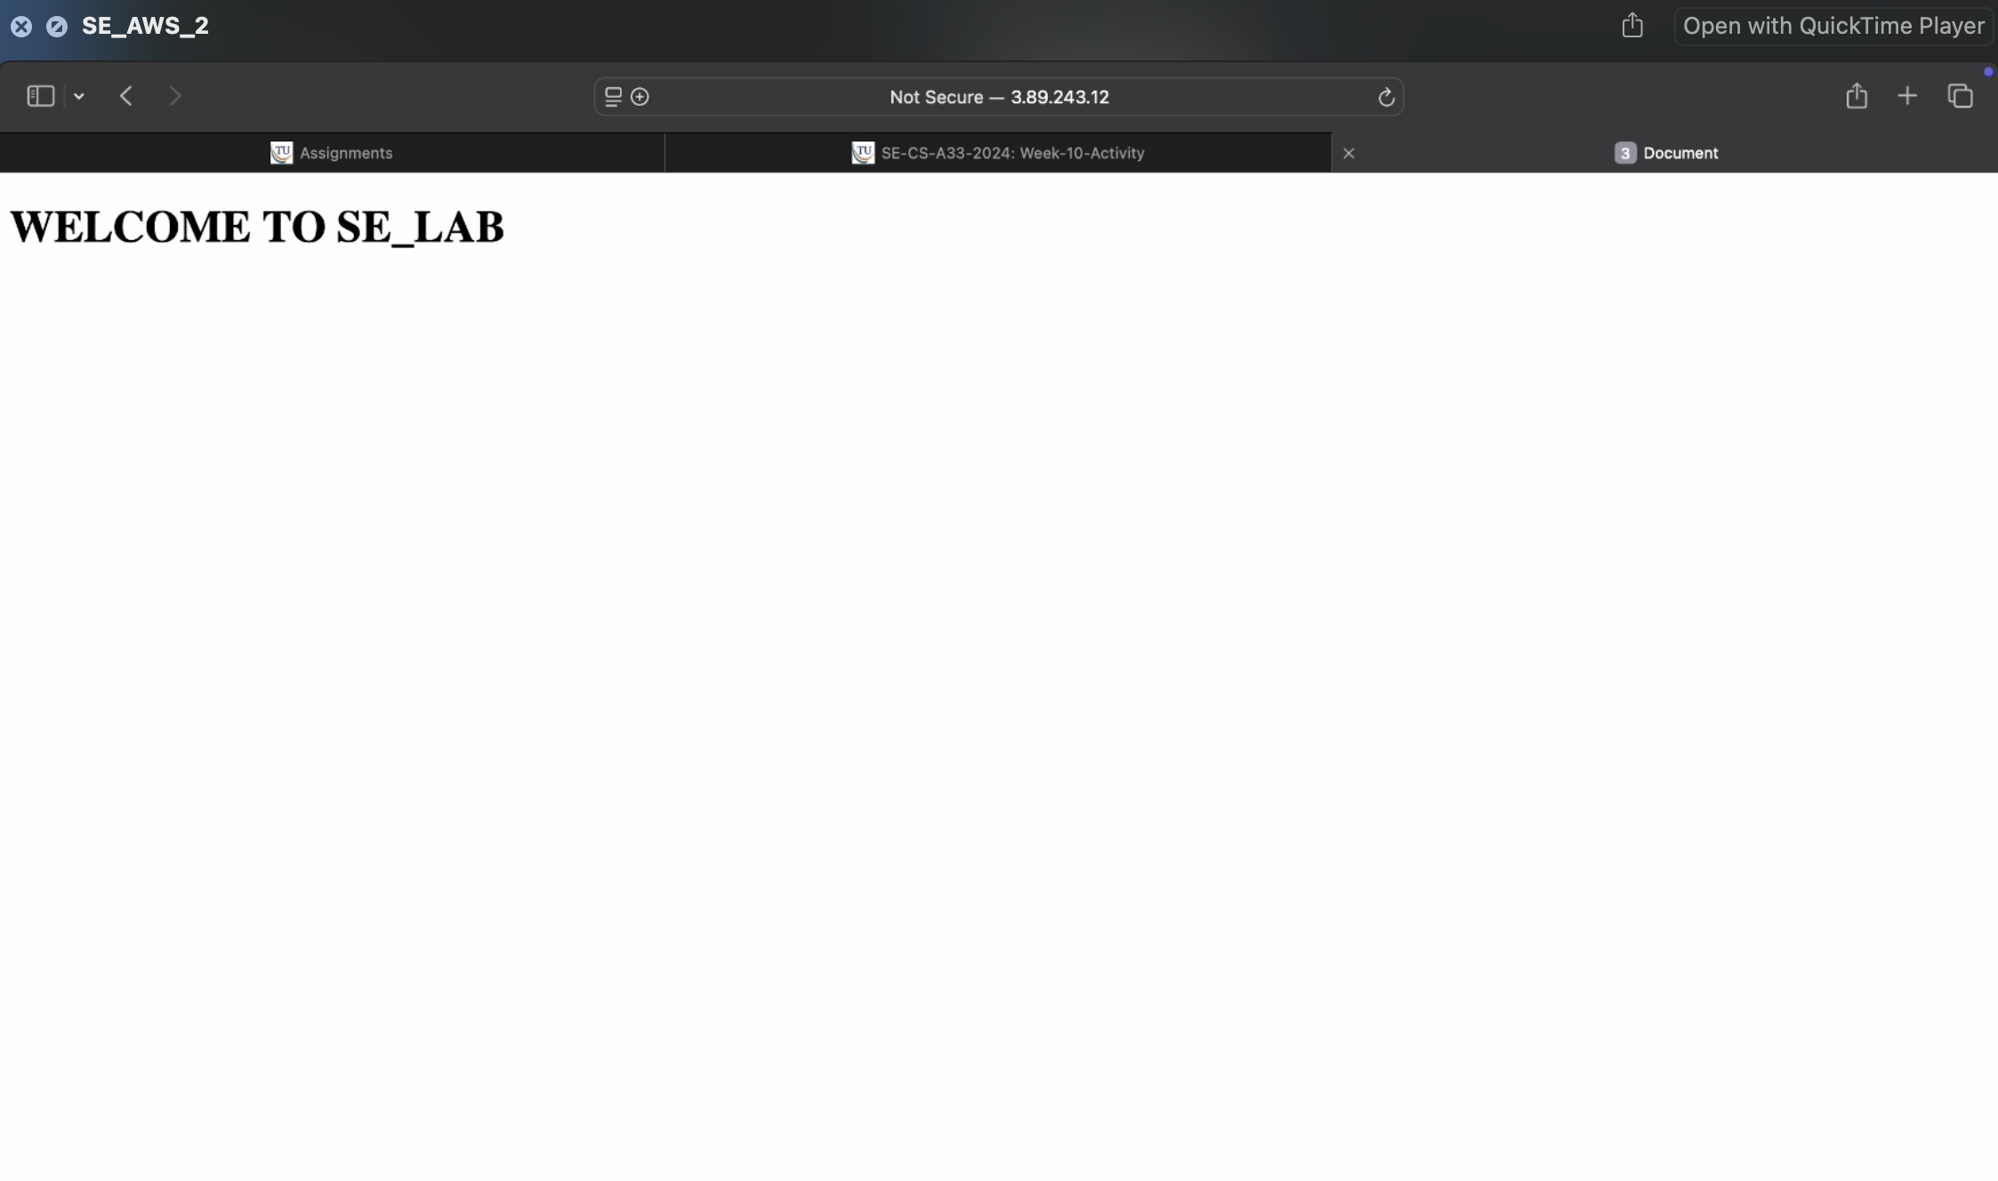

Run the following command to stop the container

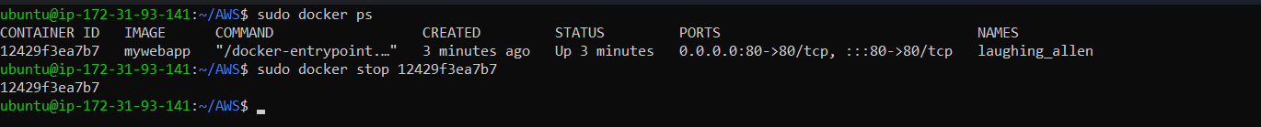

Click on terminate instances



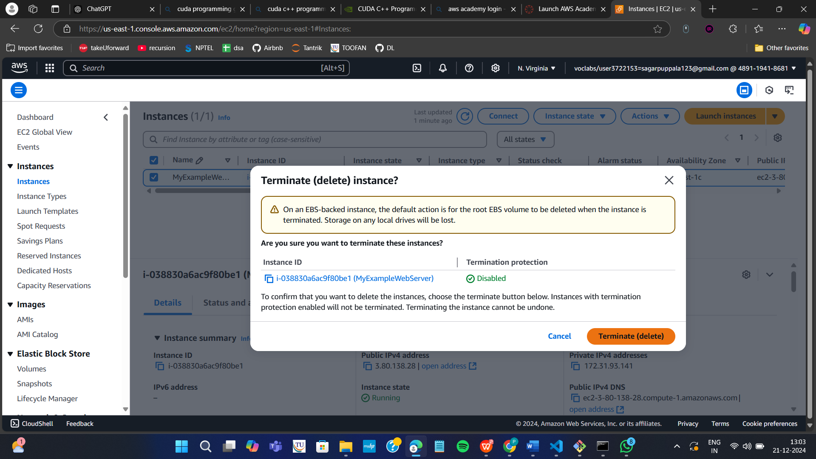

Now click on end lab

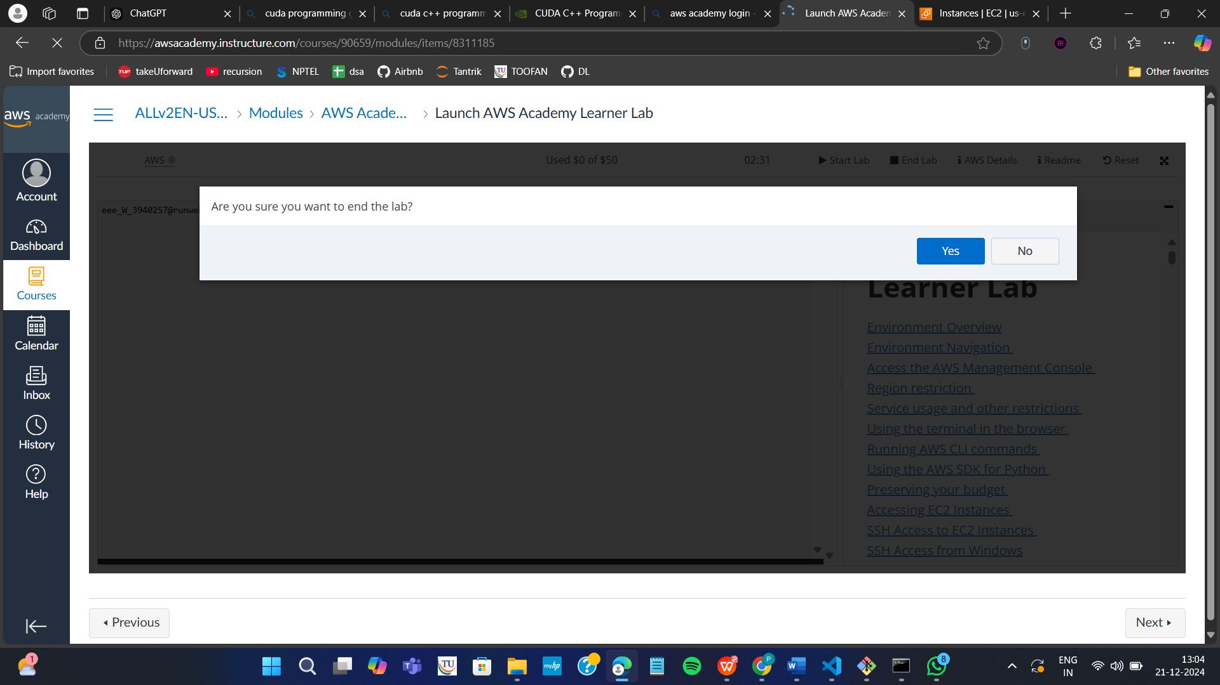

2 MAVEN WEB PROJECT DEPLOYMENT IN AWS

Click on start lab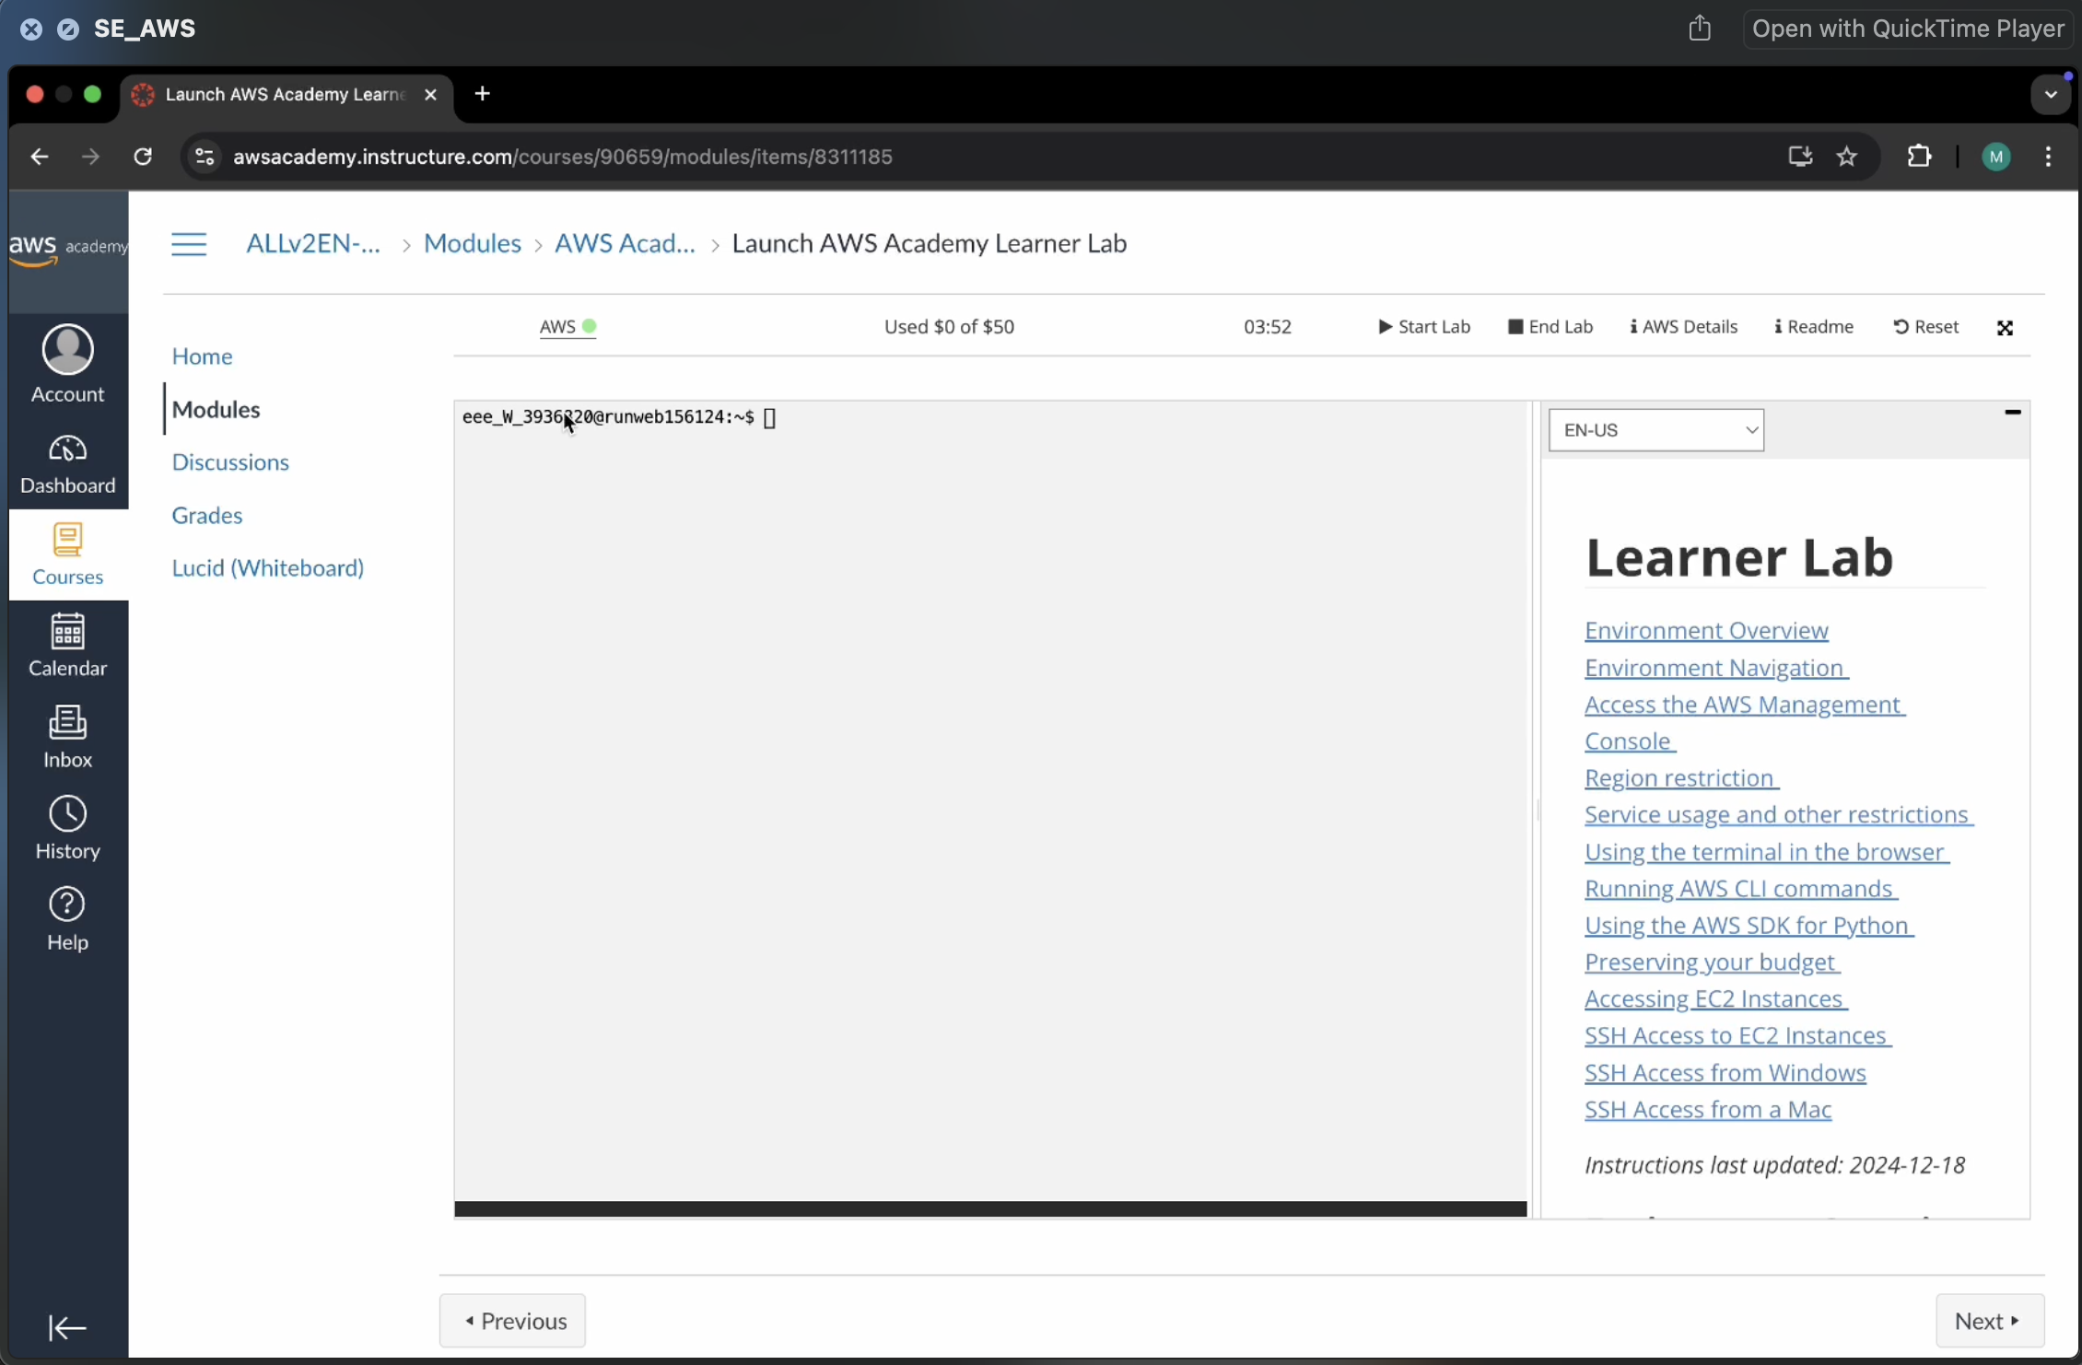



Click on AWS



Click on EC2

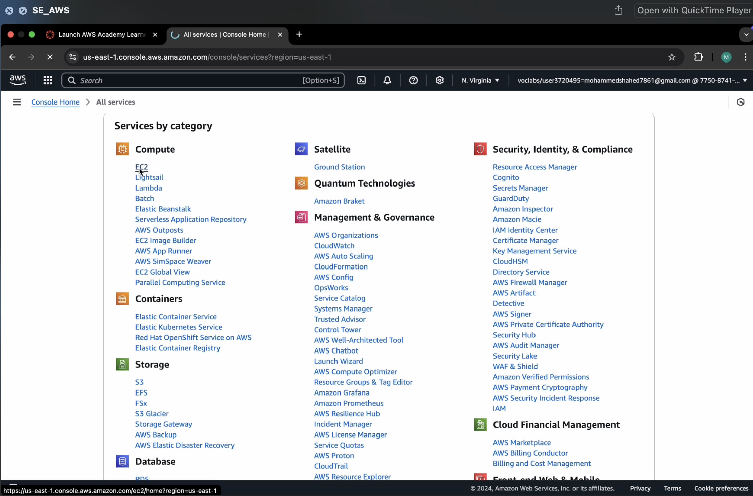

Click on launch instance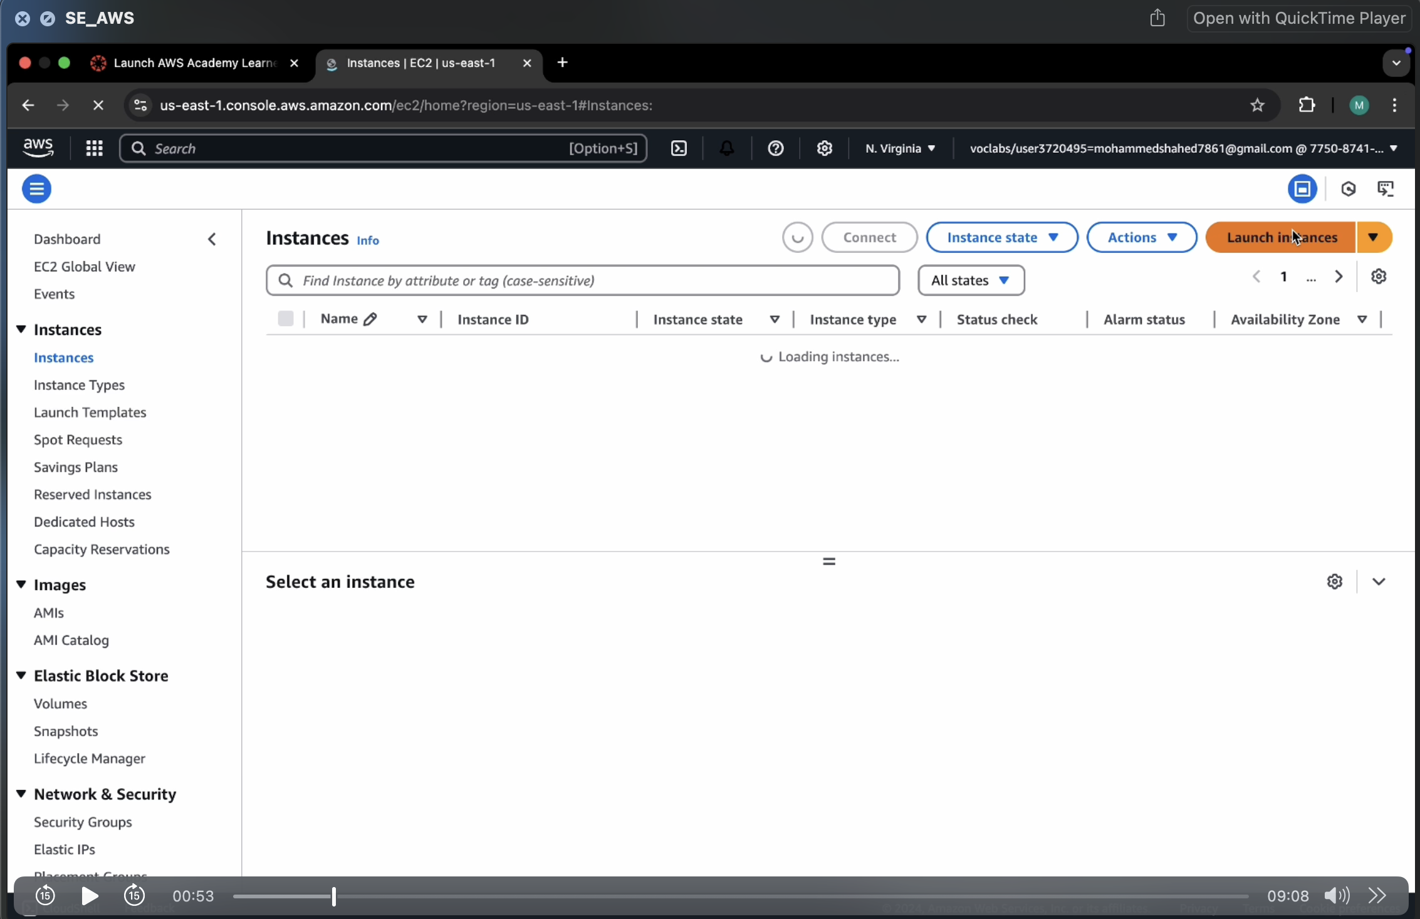

Give name

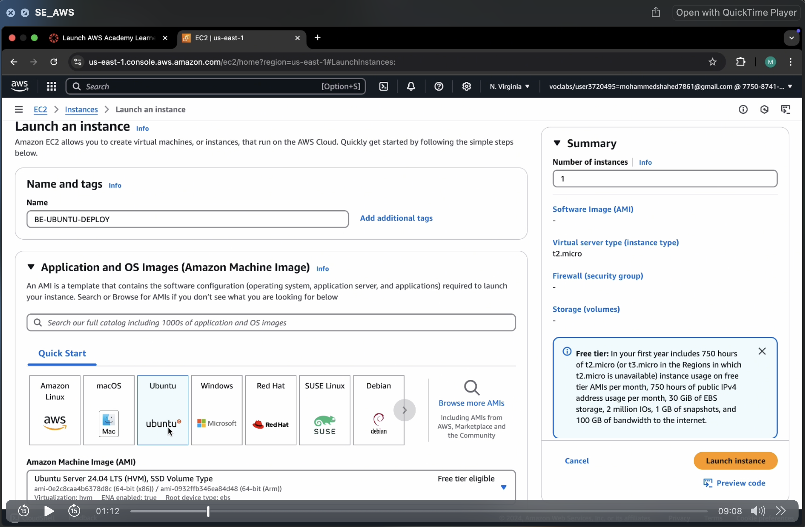

Create new key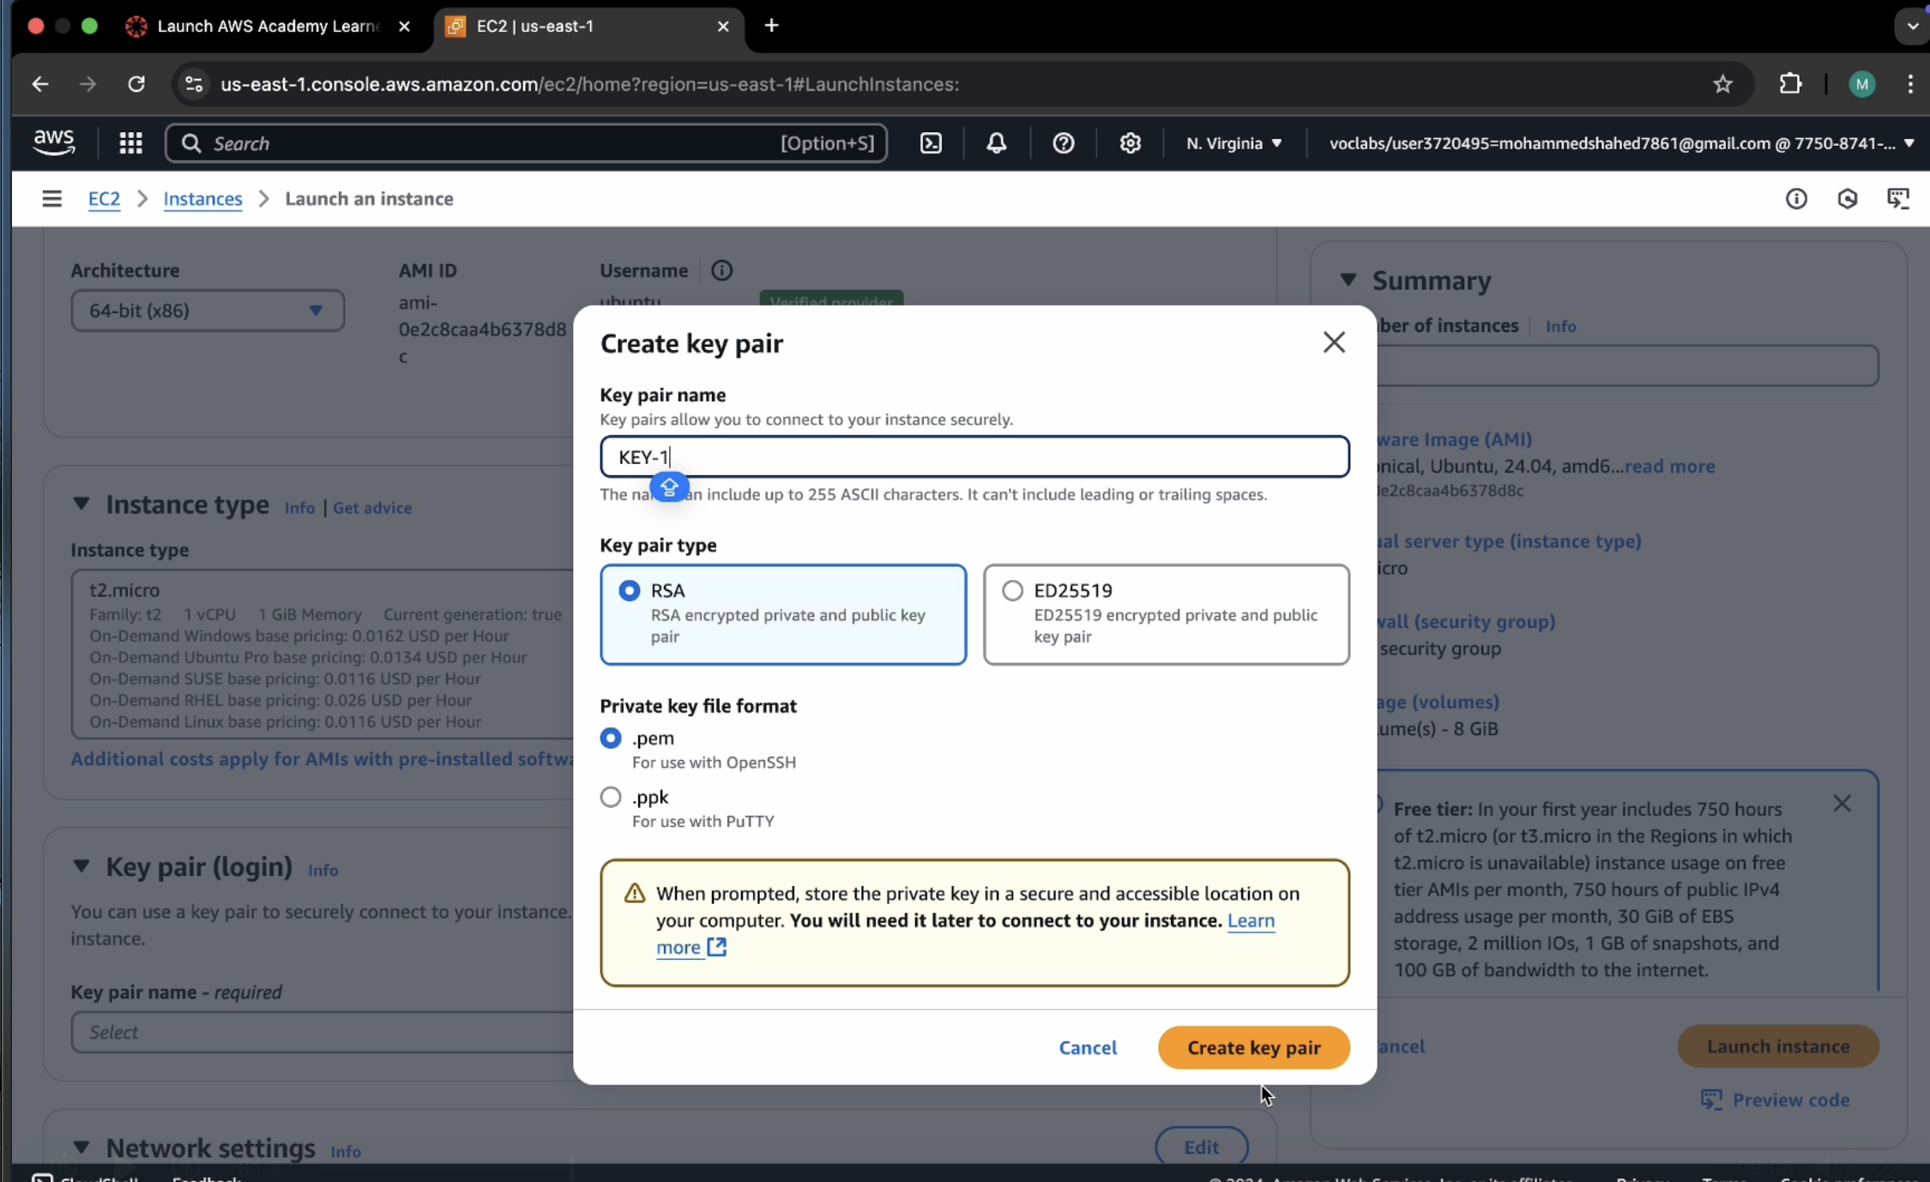

Check the boxes under network and click on launch instance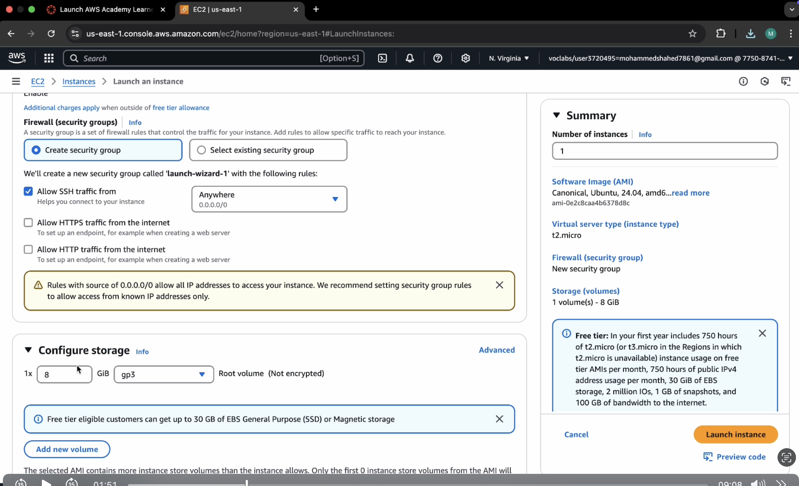

Click on instances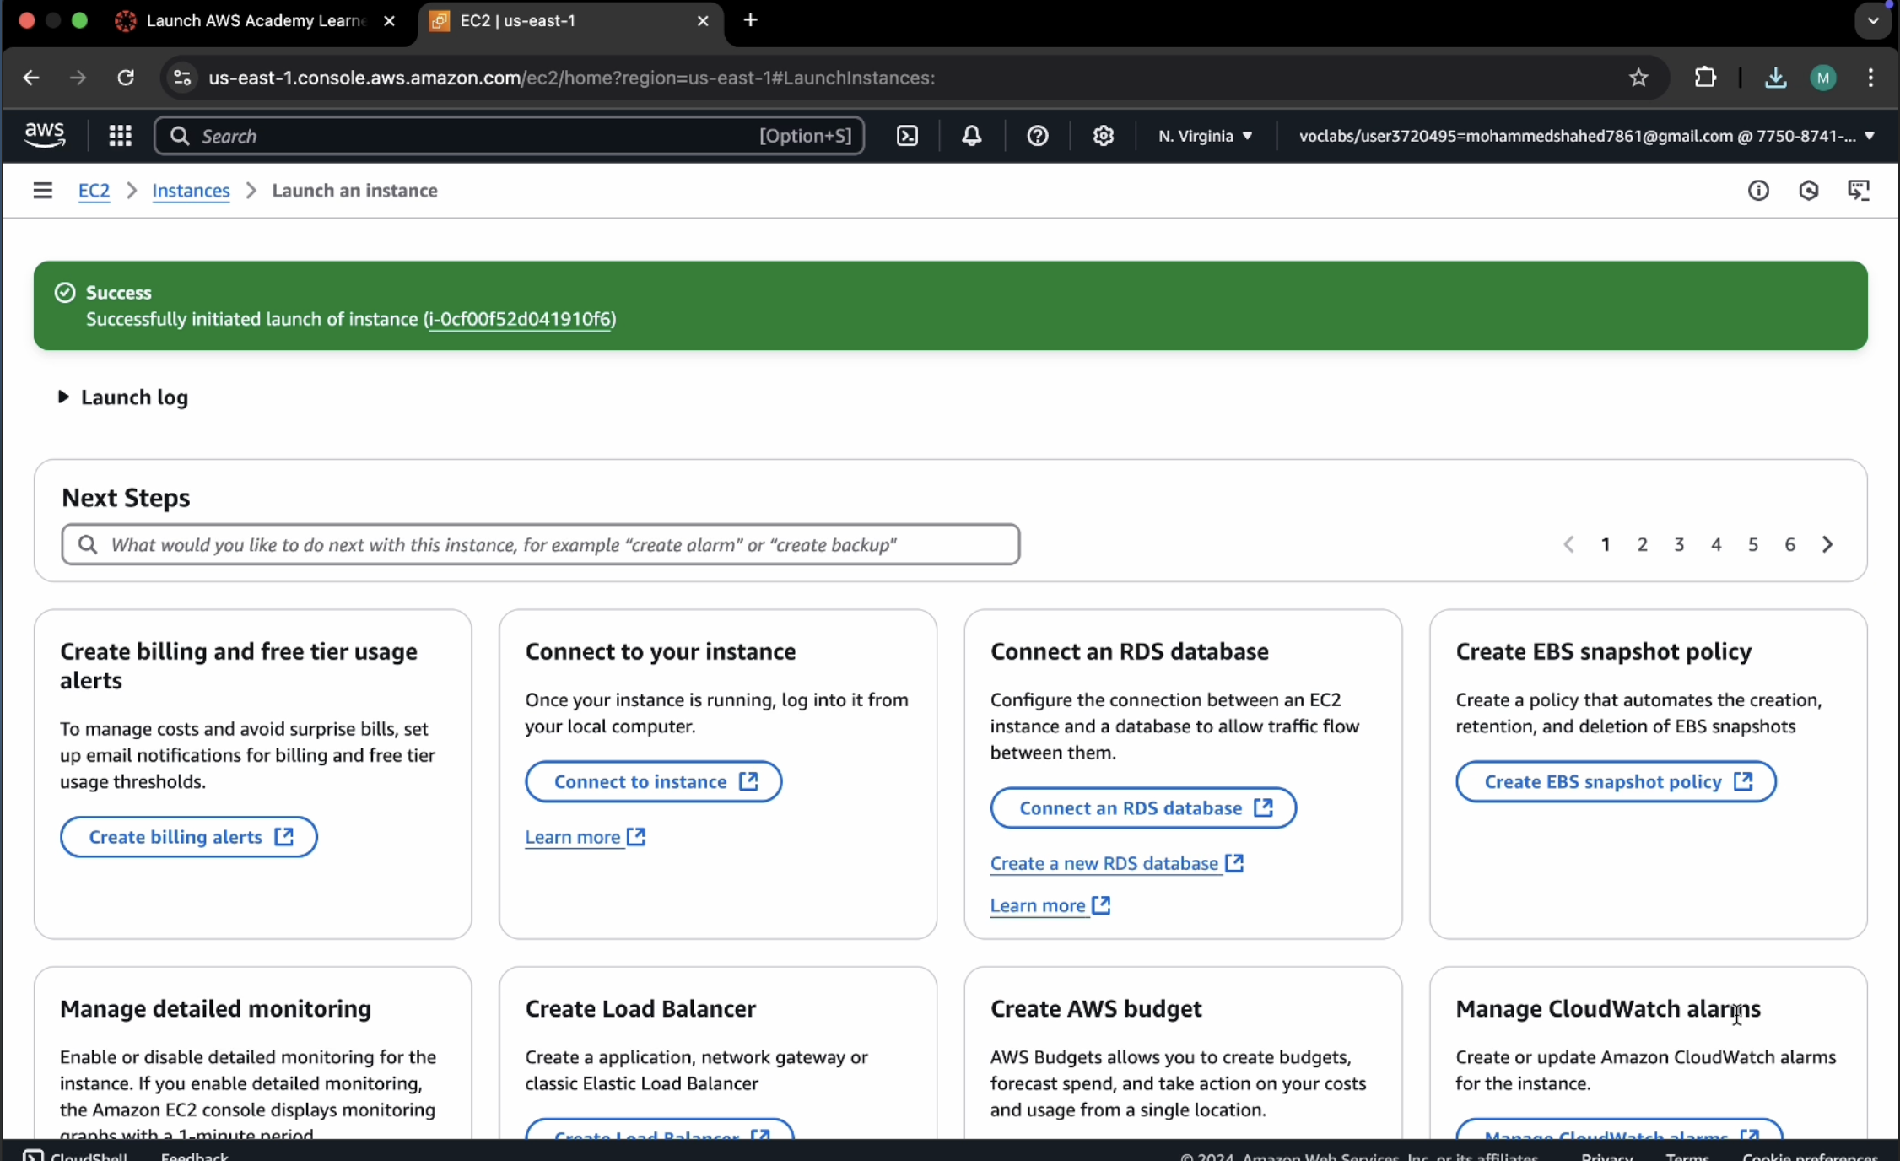

Click on connect after checking the box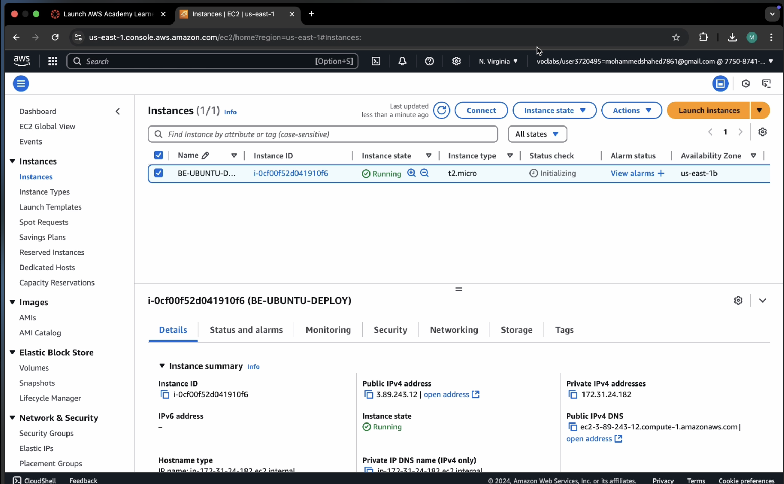

Copy ssh command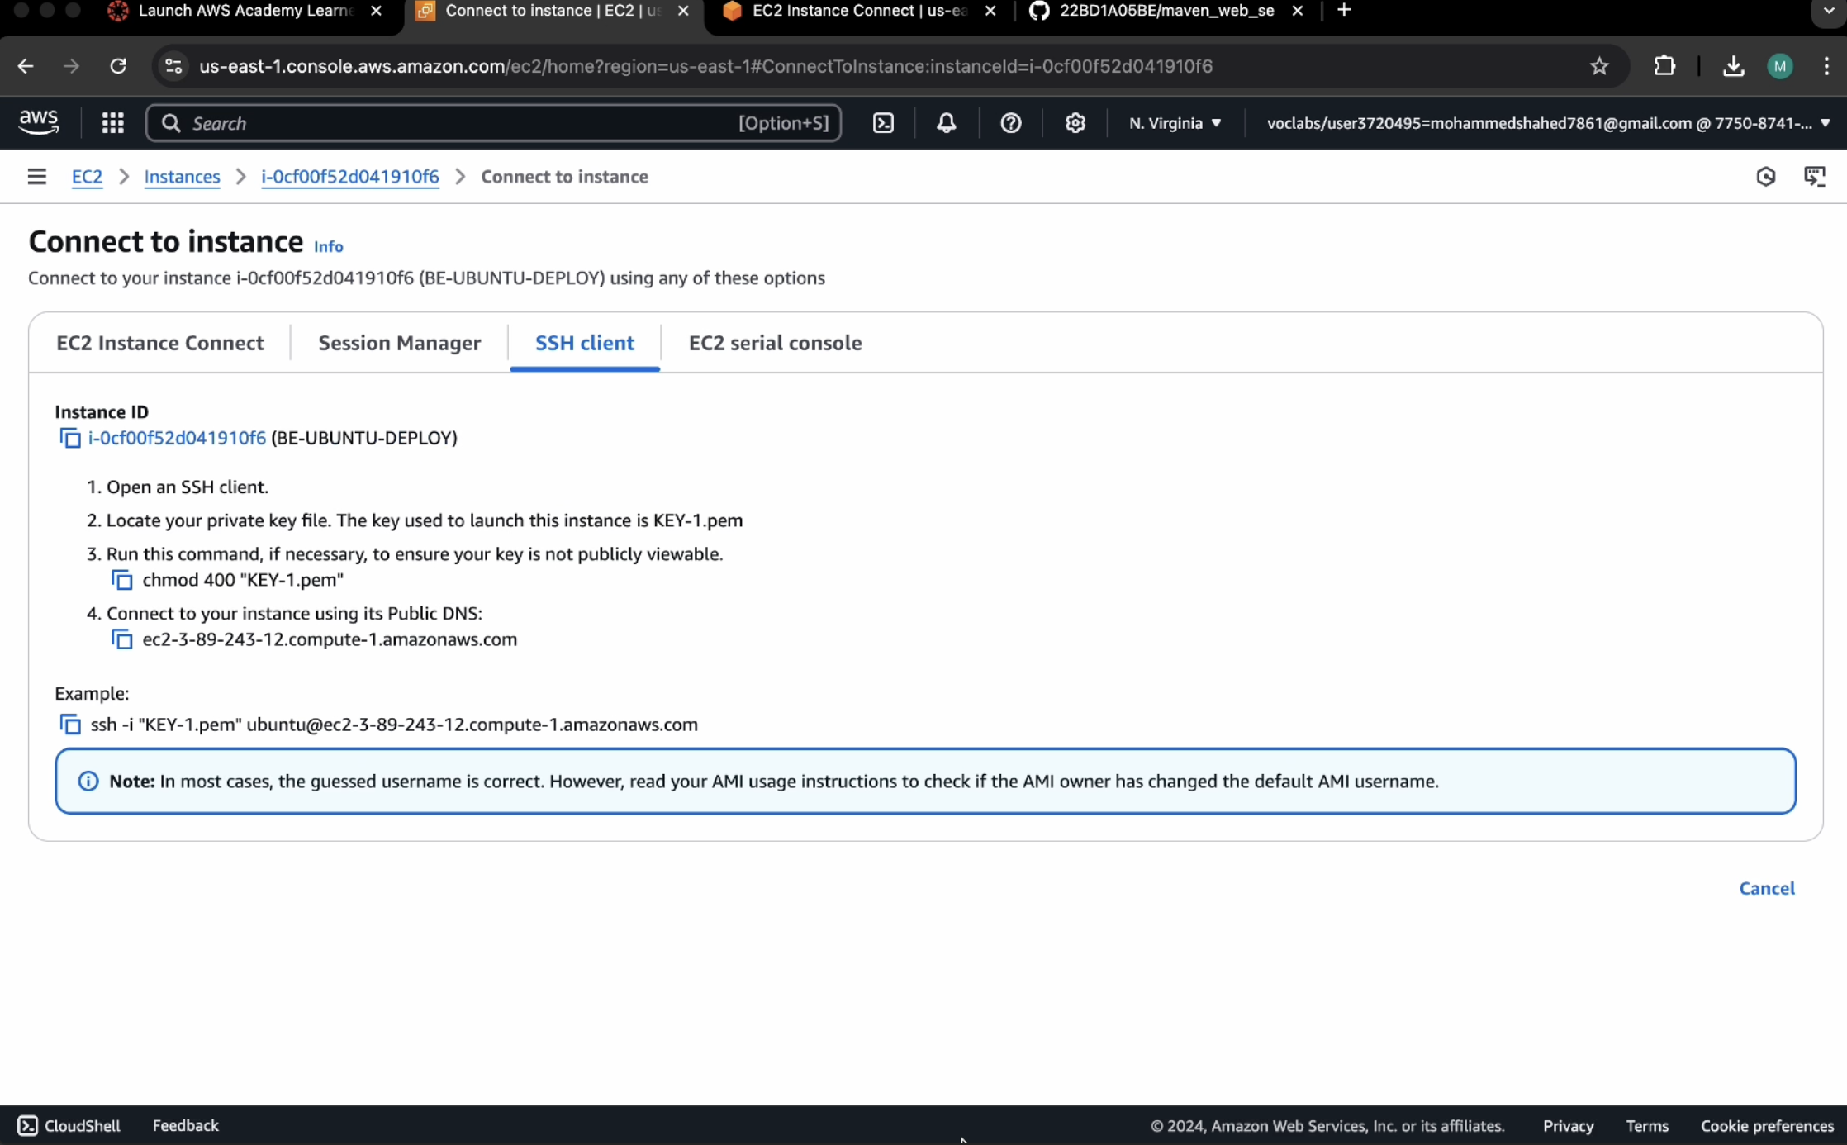

Open the terminal, Navigate to the path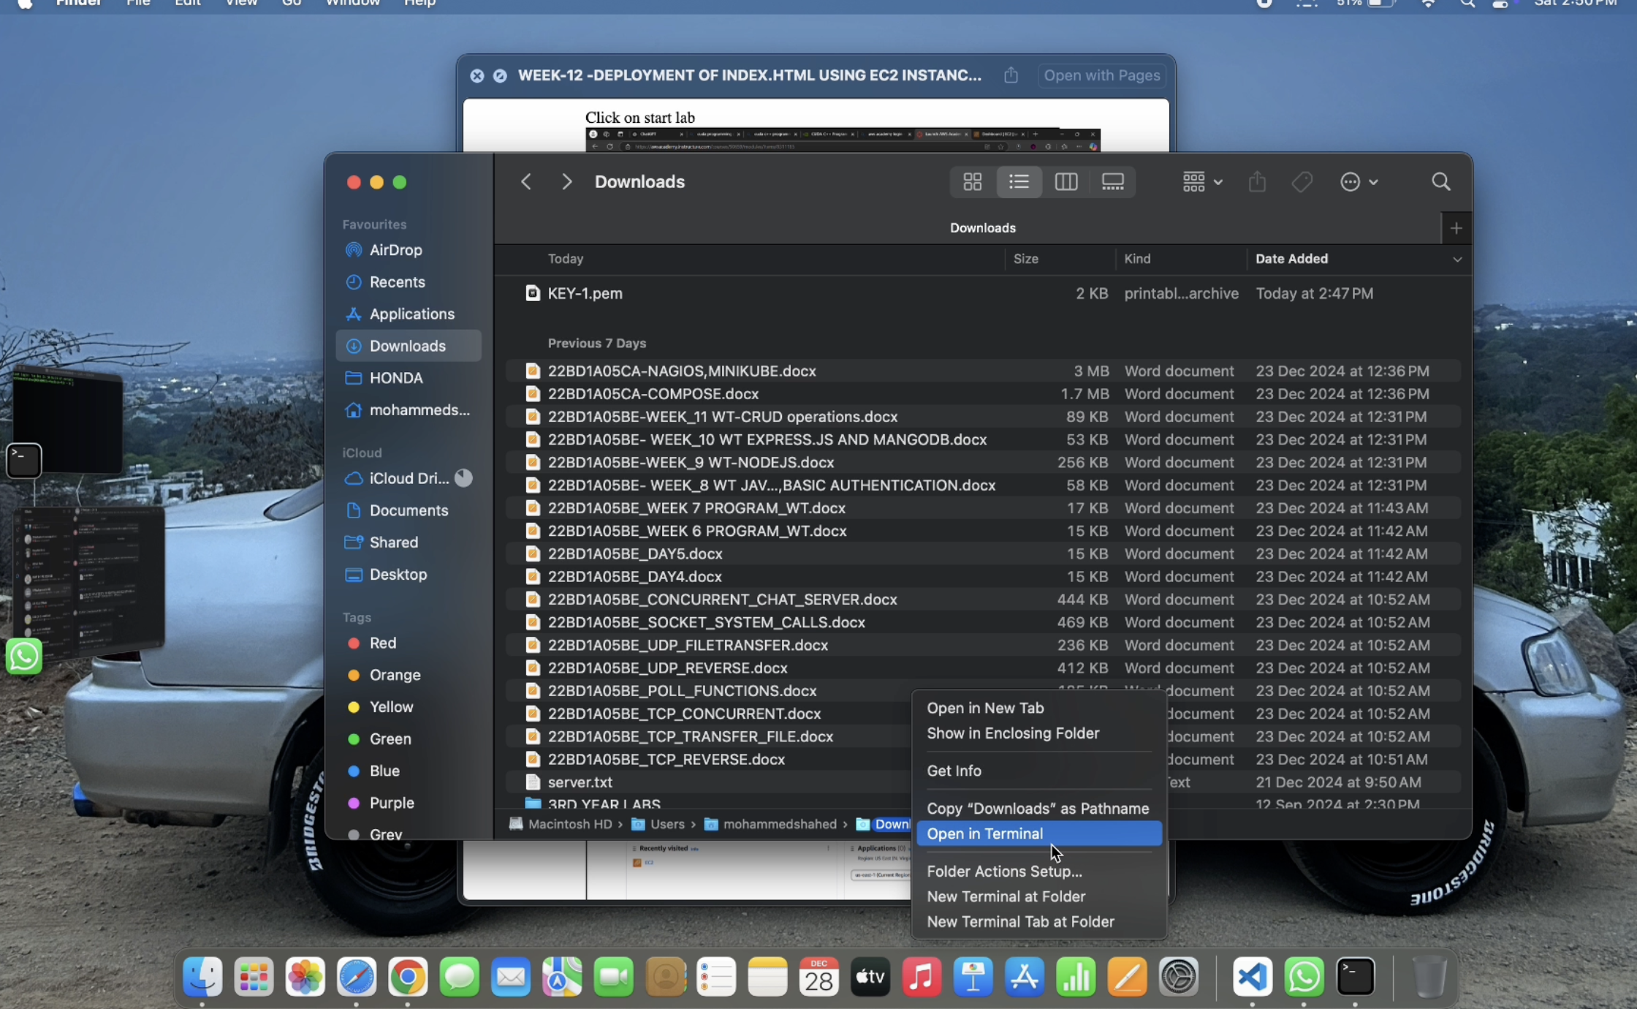

Run the ssh command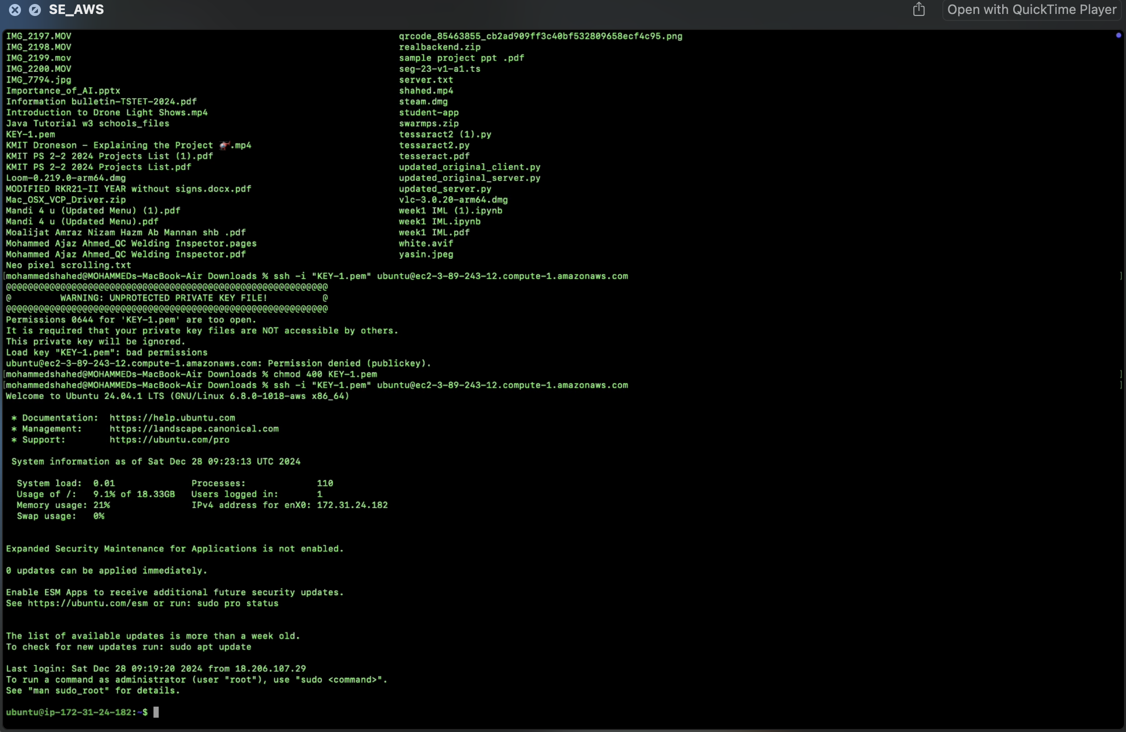

Run the following commands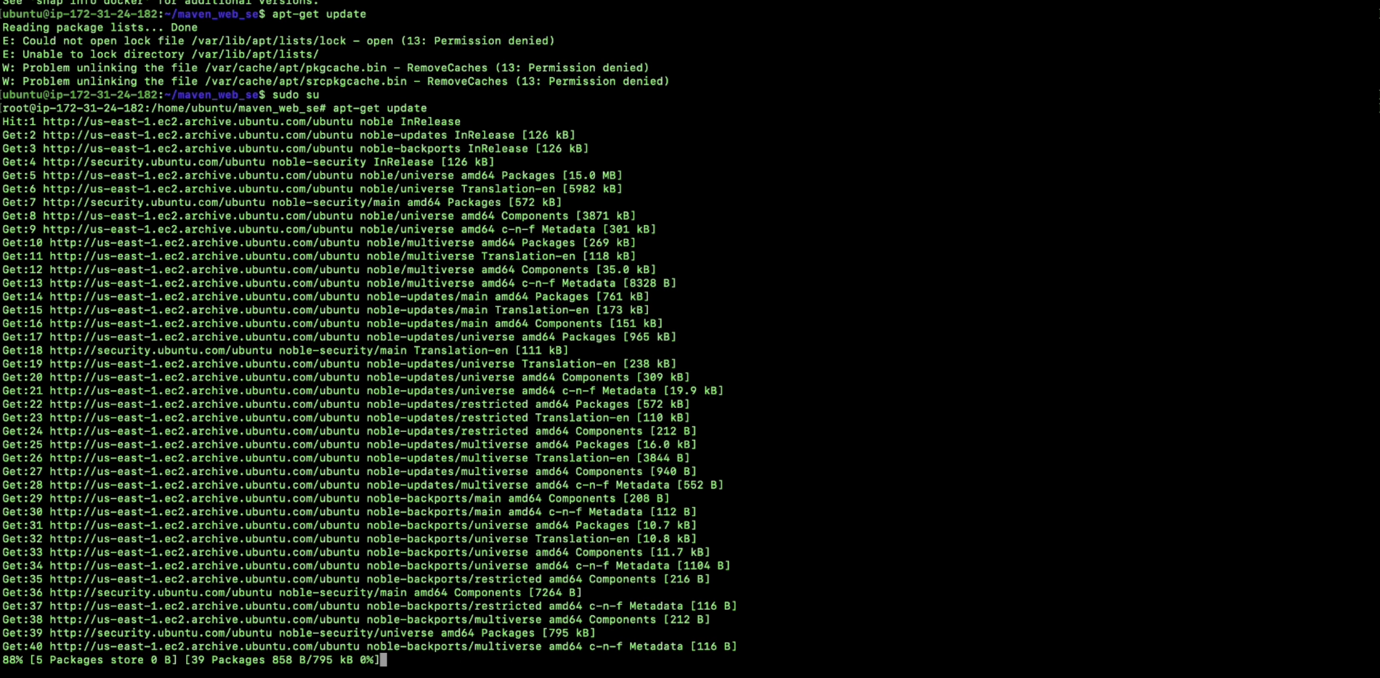

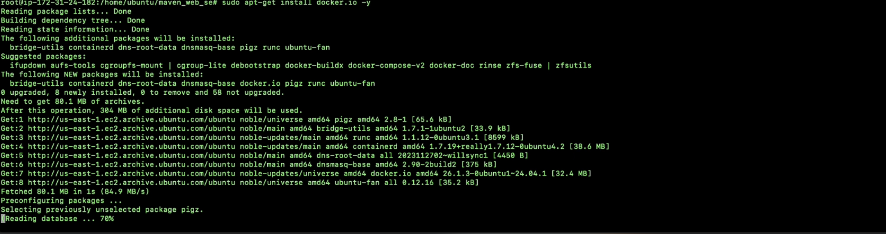

**Open MAVEN WEB PROJECT REPO in github and copy http link**

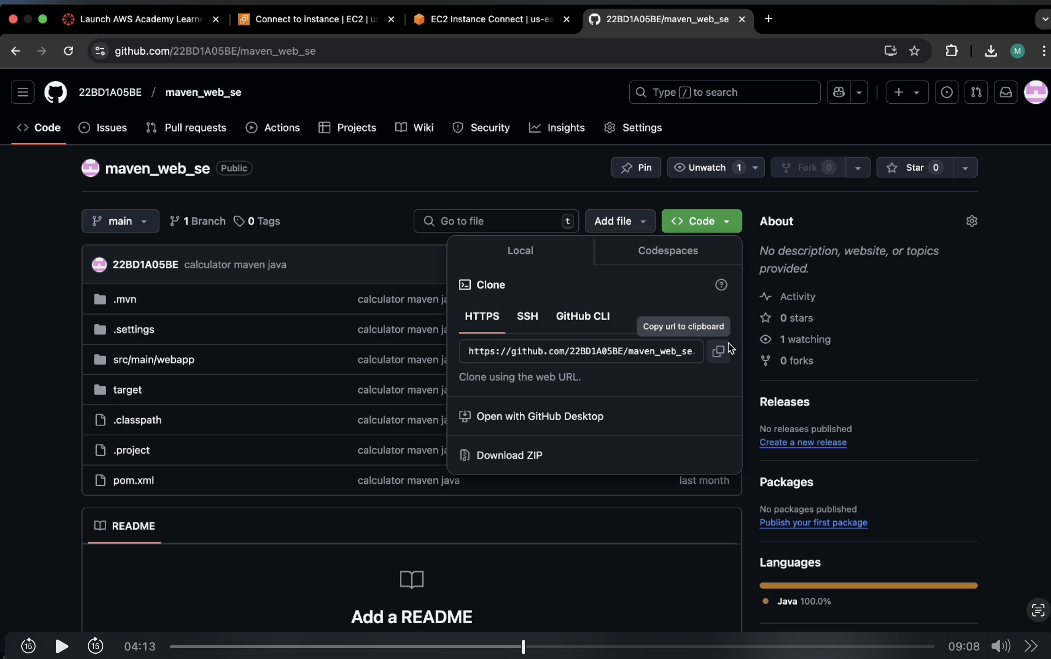

**Clone the repository**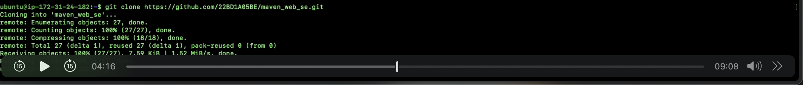

**If your repository is in main run following**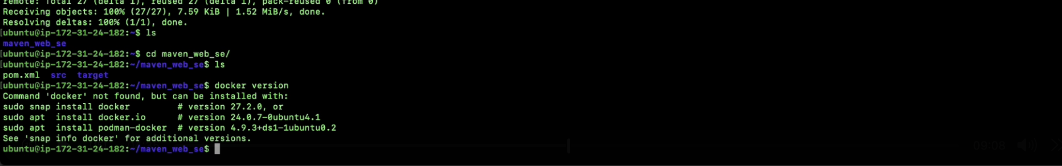



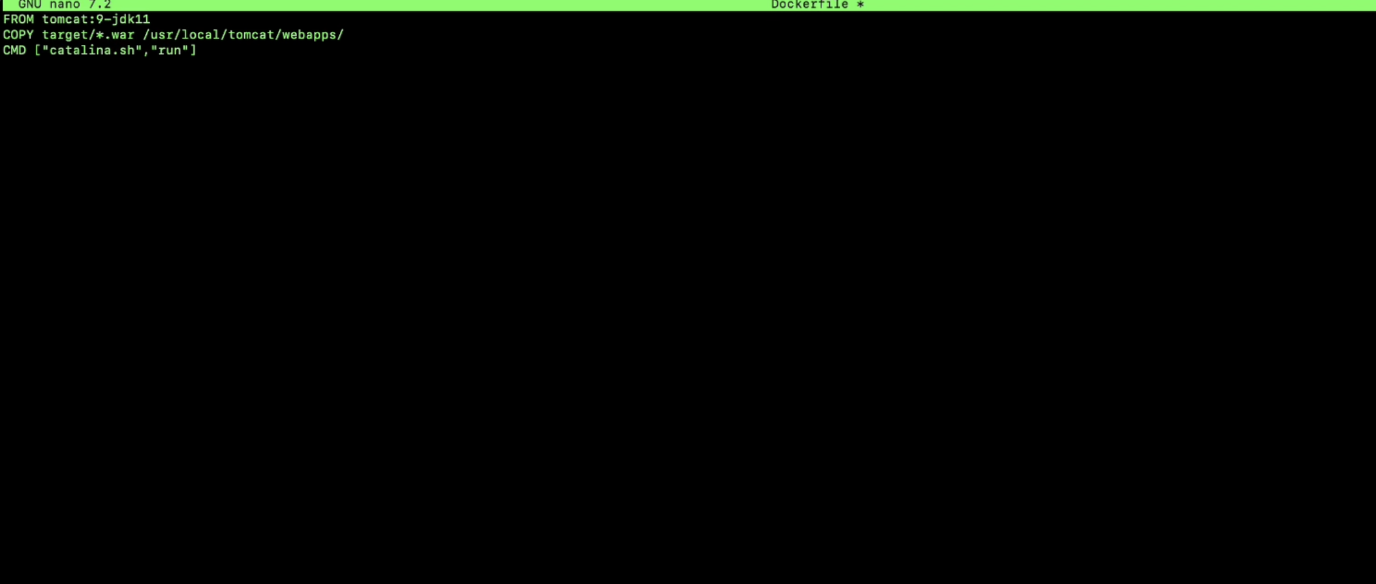

**Build docker image**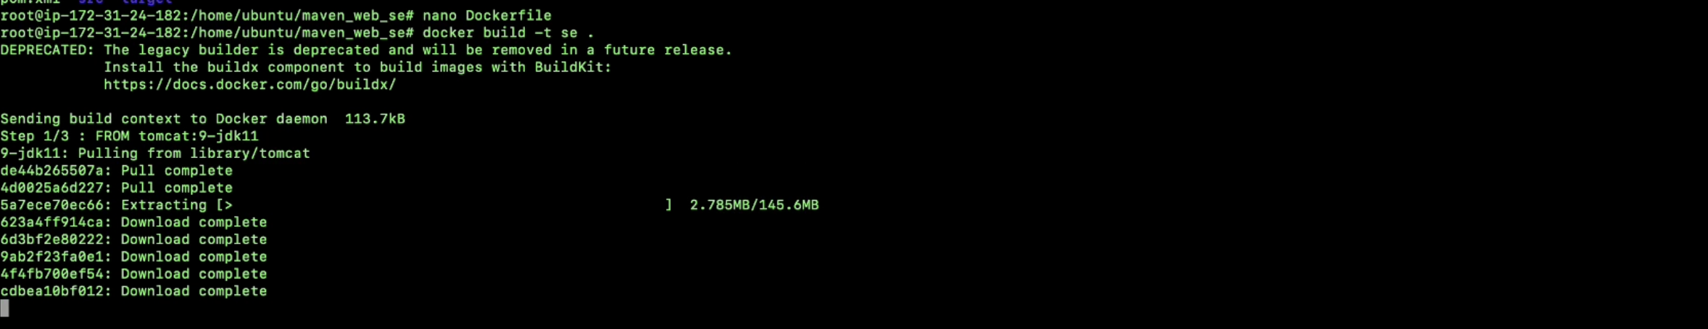

**Run the container**

**Copy public ipv4**

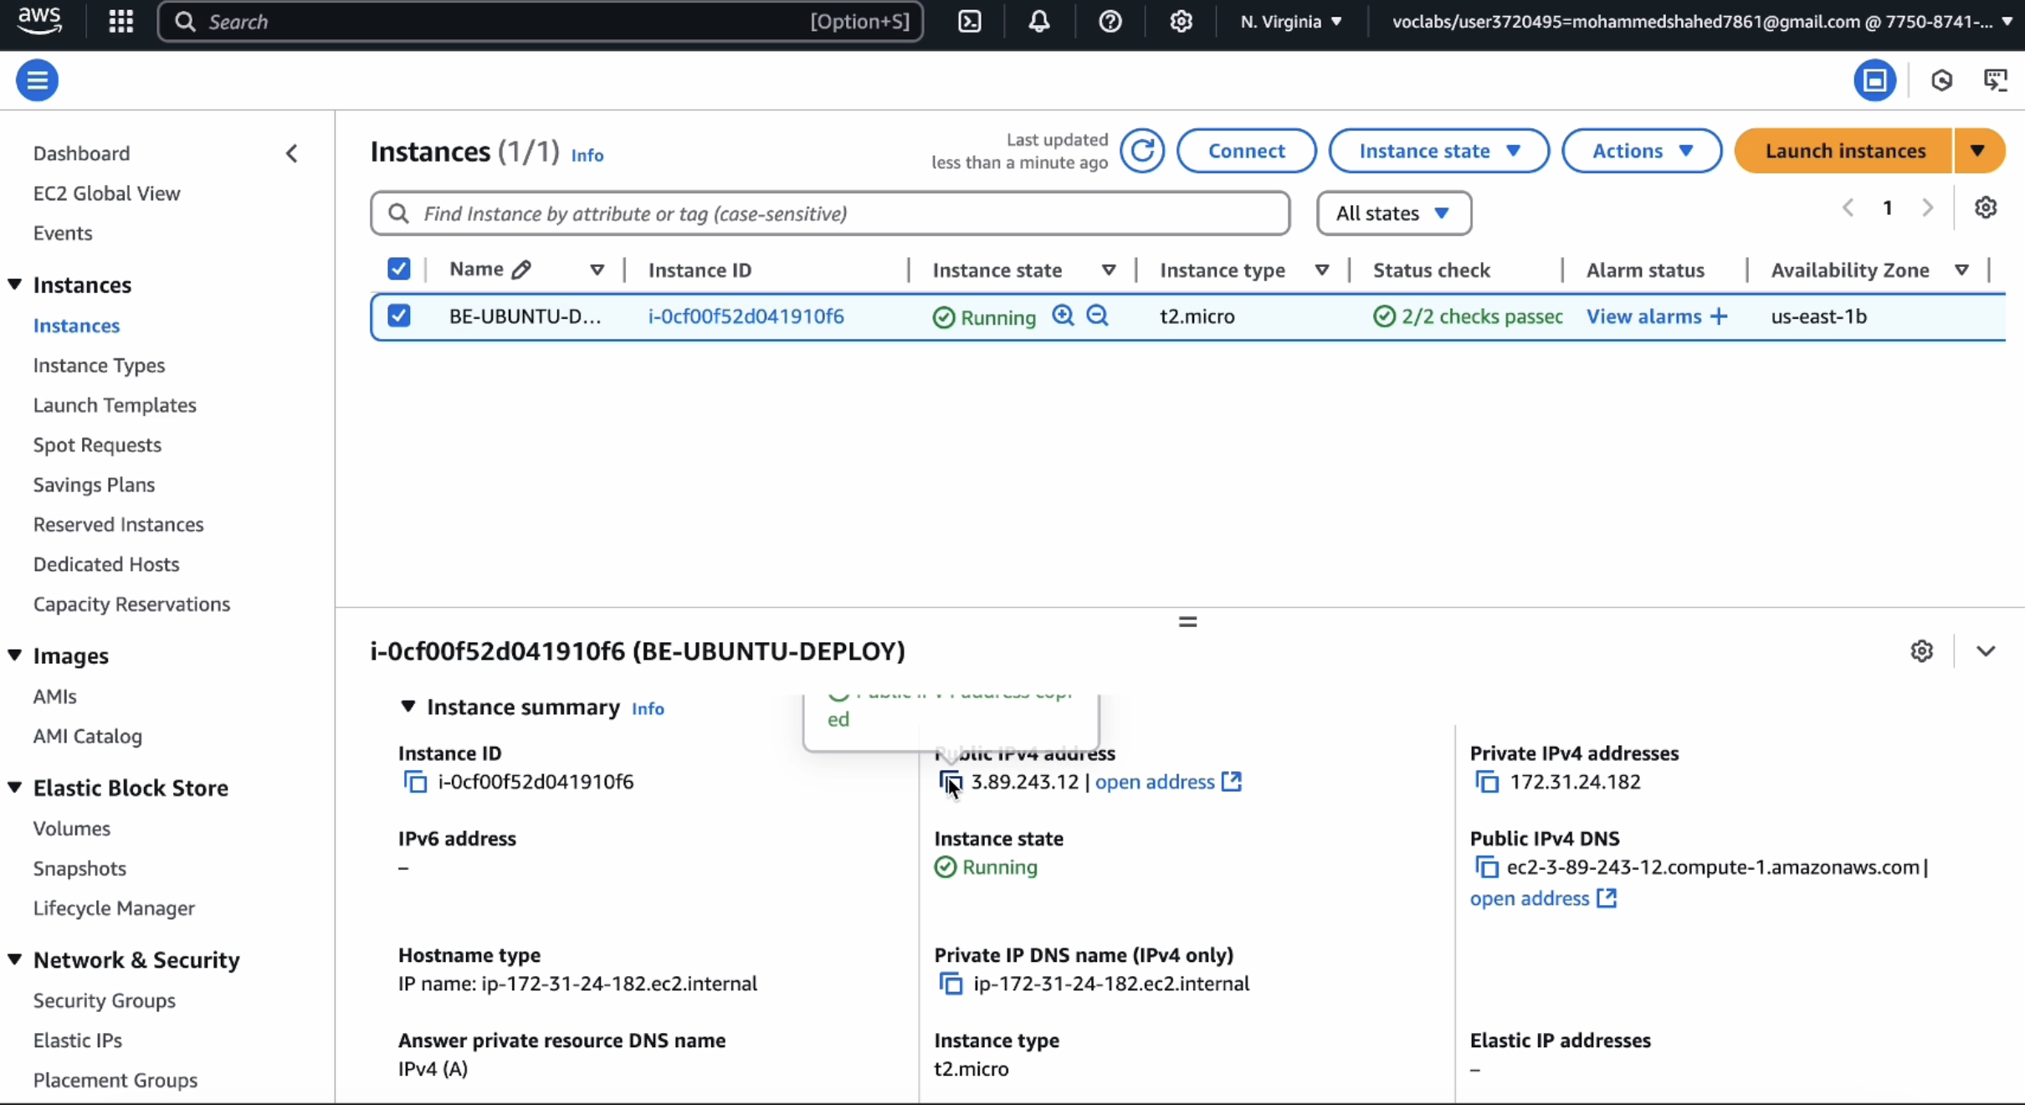

**Enter this url in browser and click enter**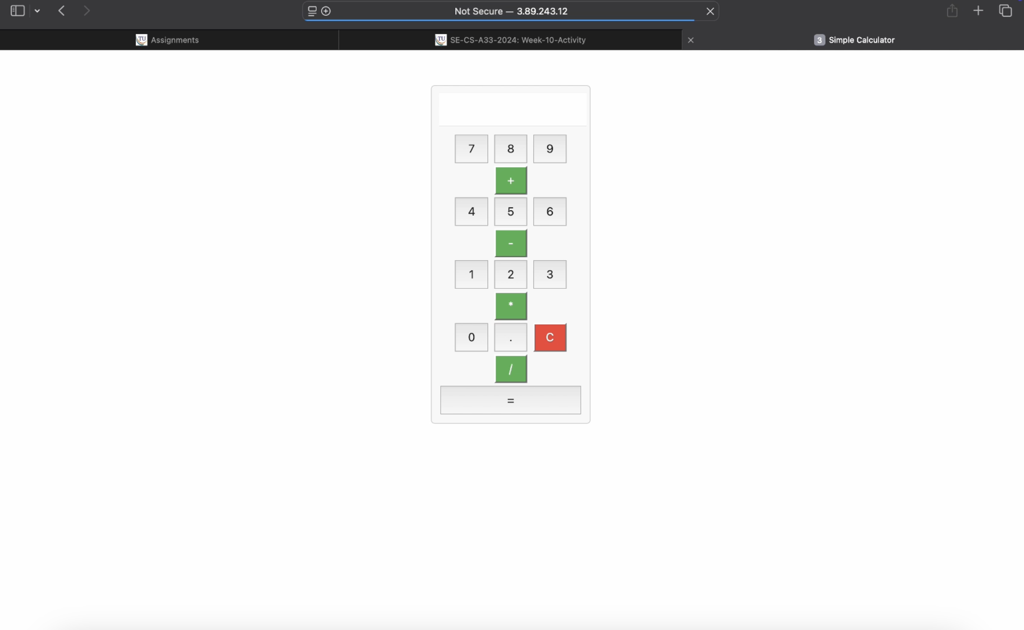

**If your app is not running goto security and Click on security groups**

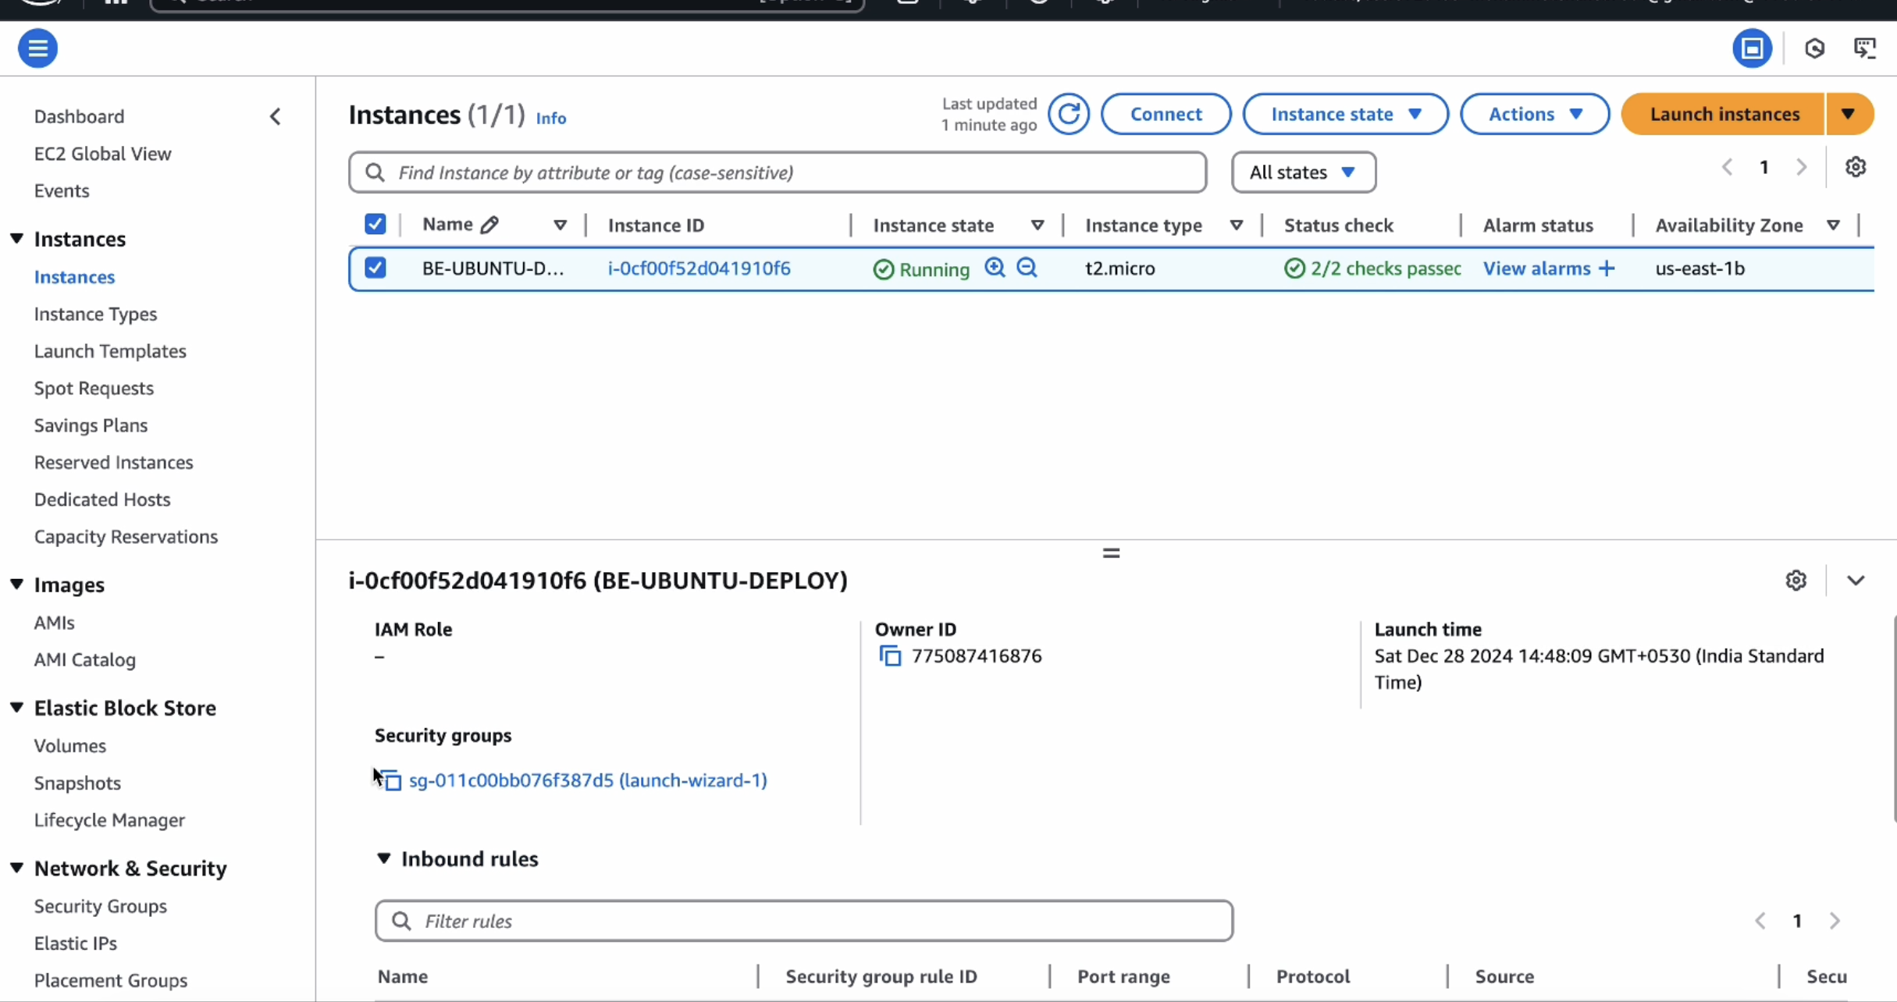

**Click on edit inbound rules**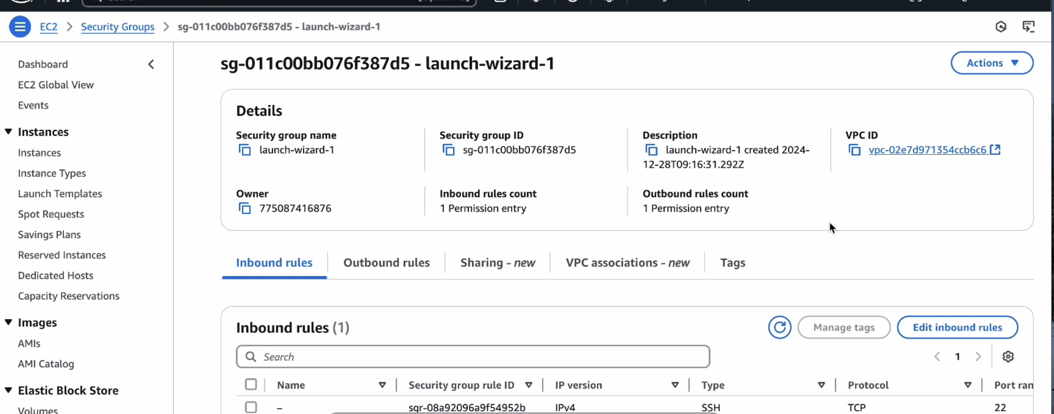

**Click on add rule give port as 7070and 0.0.0.0/0 click on save**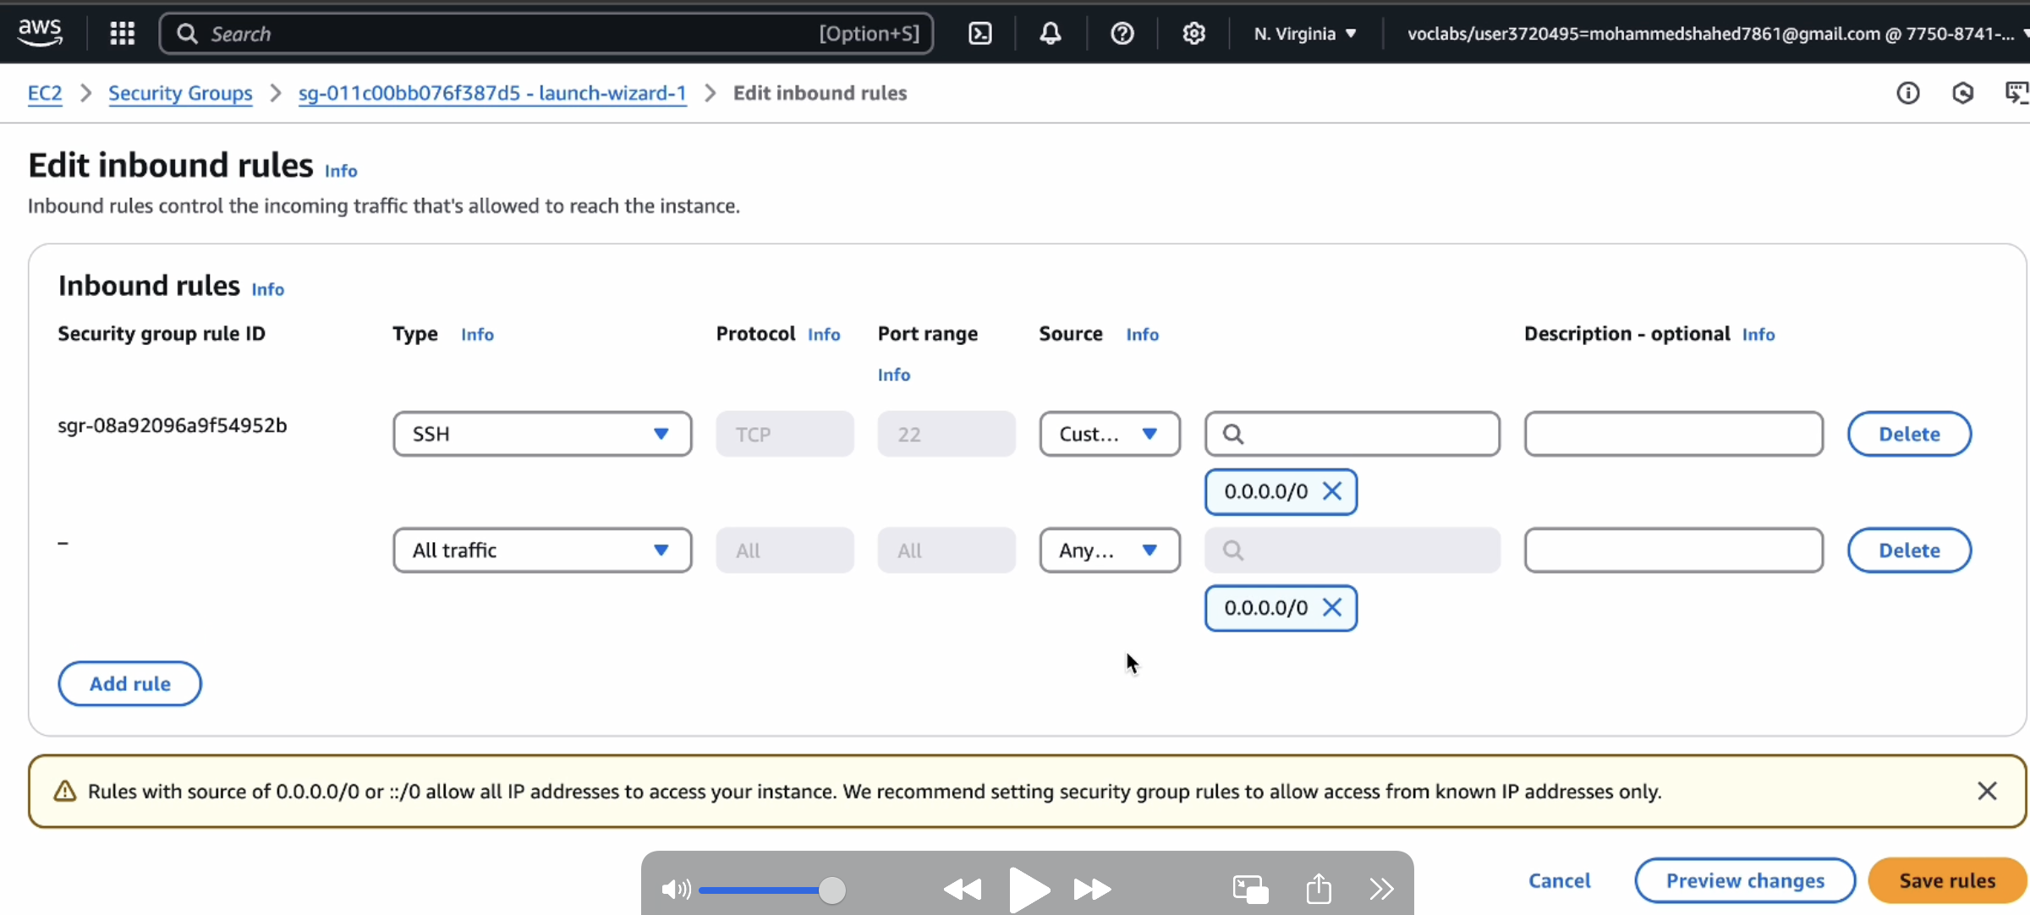

**And refresh the page to check whether the web page has loaded or not**



**If it is loaded you have successfully deployed you maven web project In your ec2 instance**

**Run the following commands to stop the container**

**Terminate your instance**



**End your lab**

